**ASSIGNMENT 1 – COMP3354**

**JAIN RAJAT, 3035453684**

Question 1.

(a)

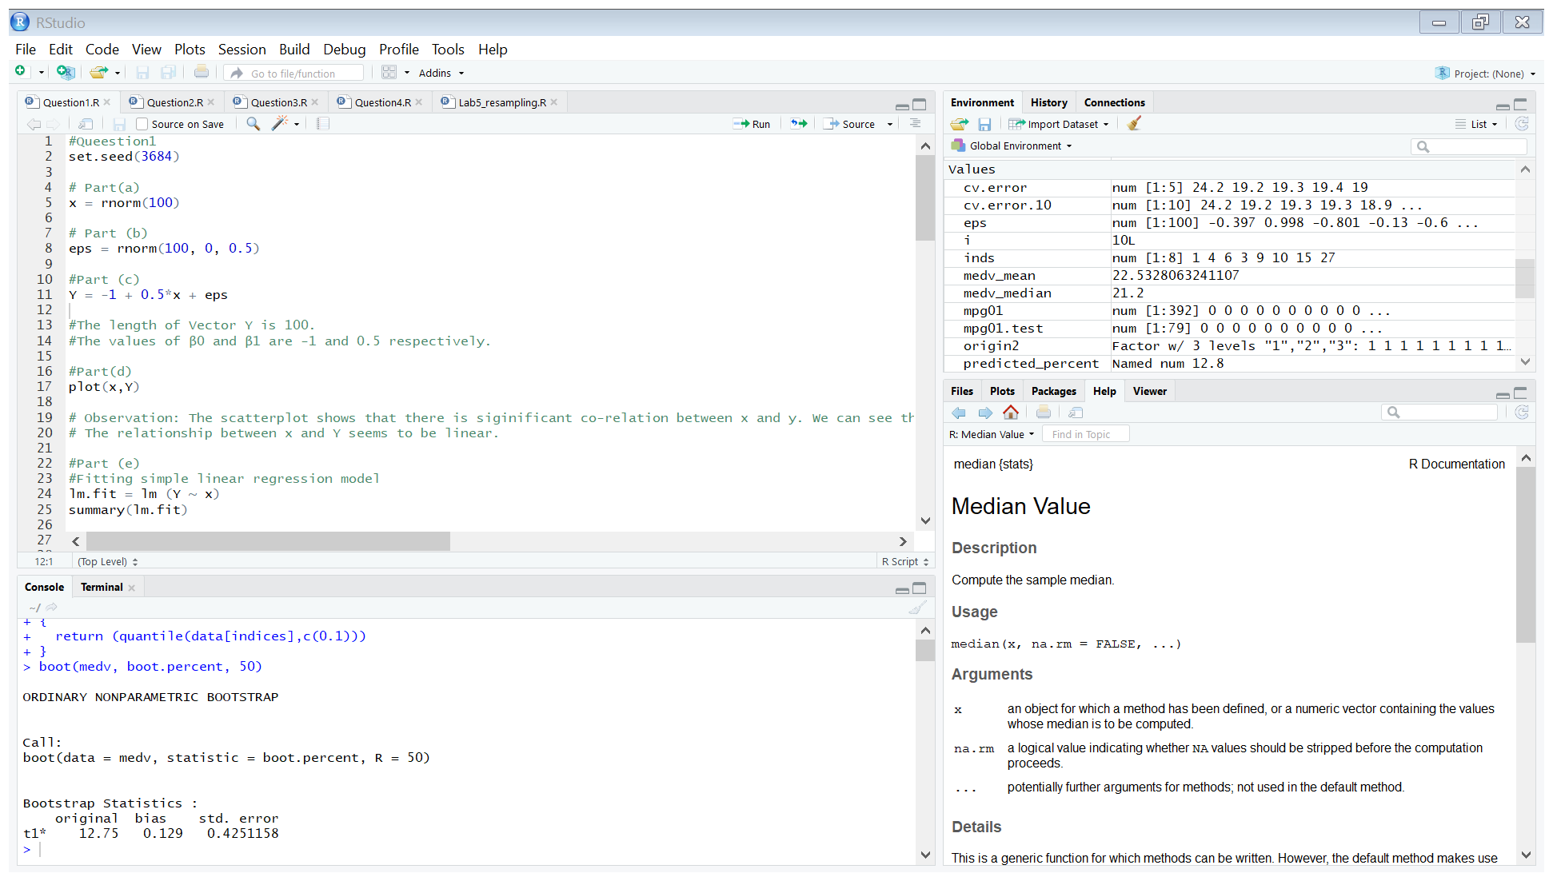

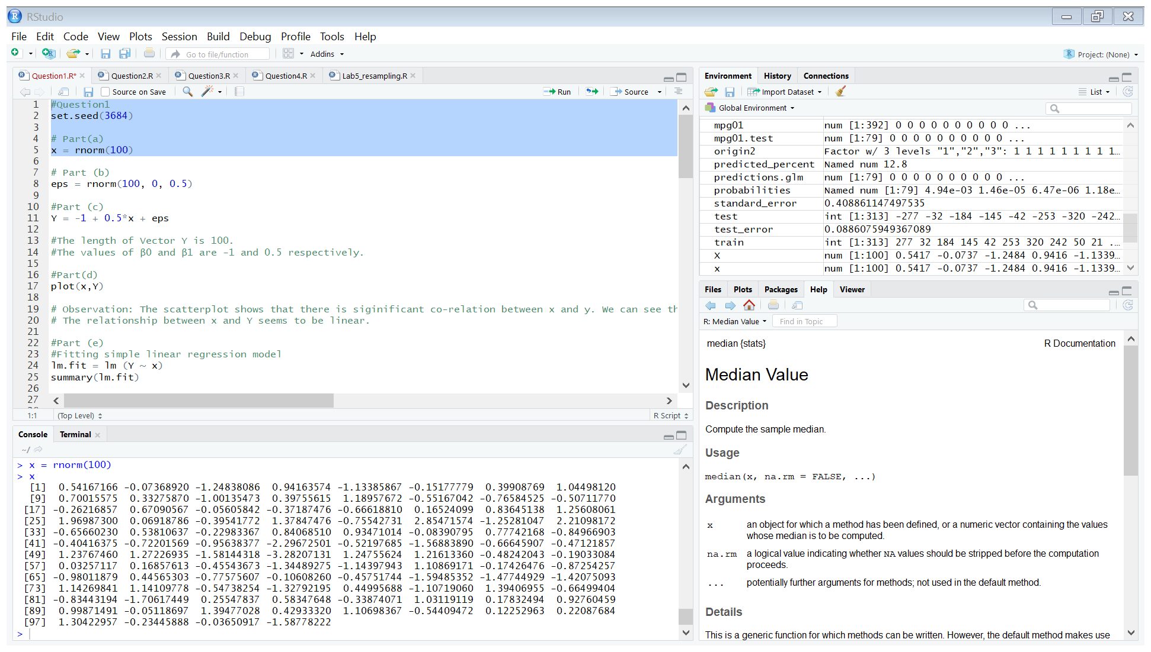

(b)

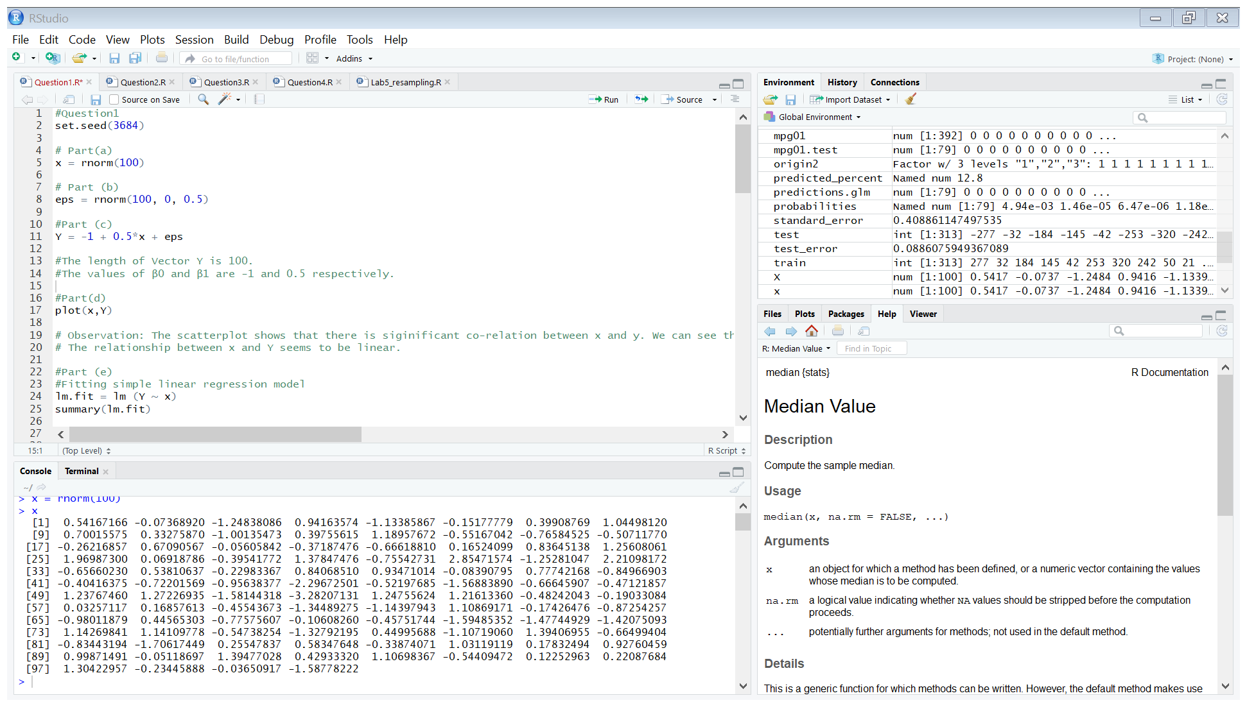

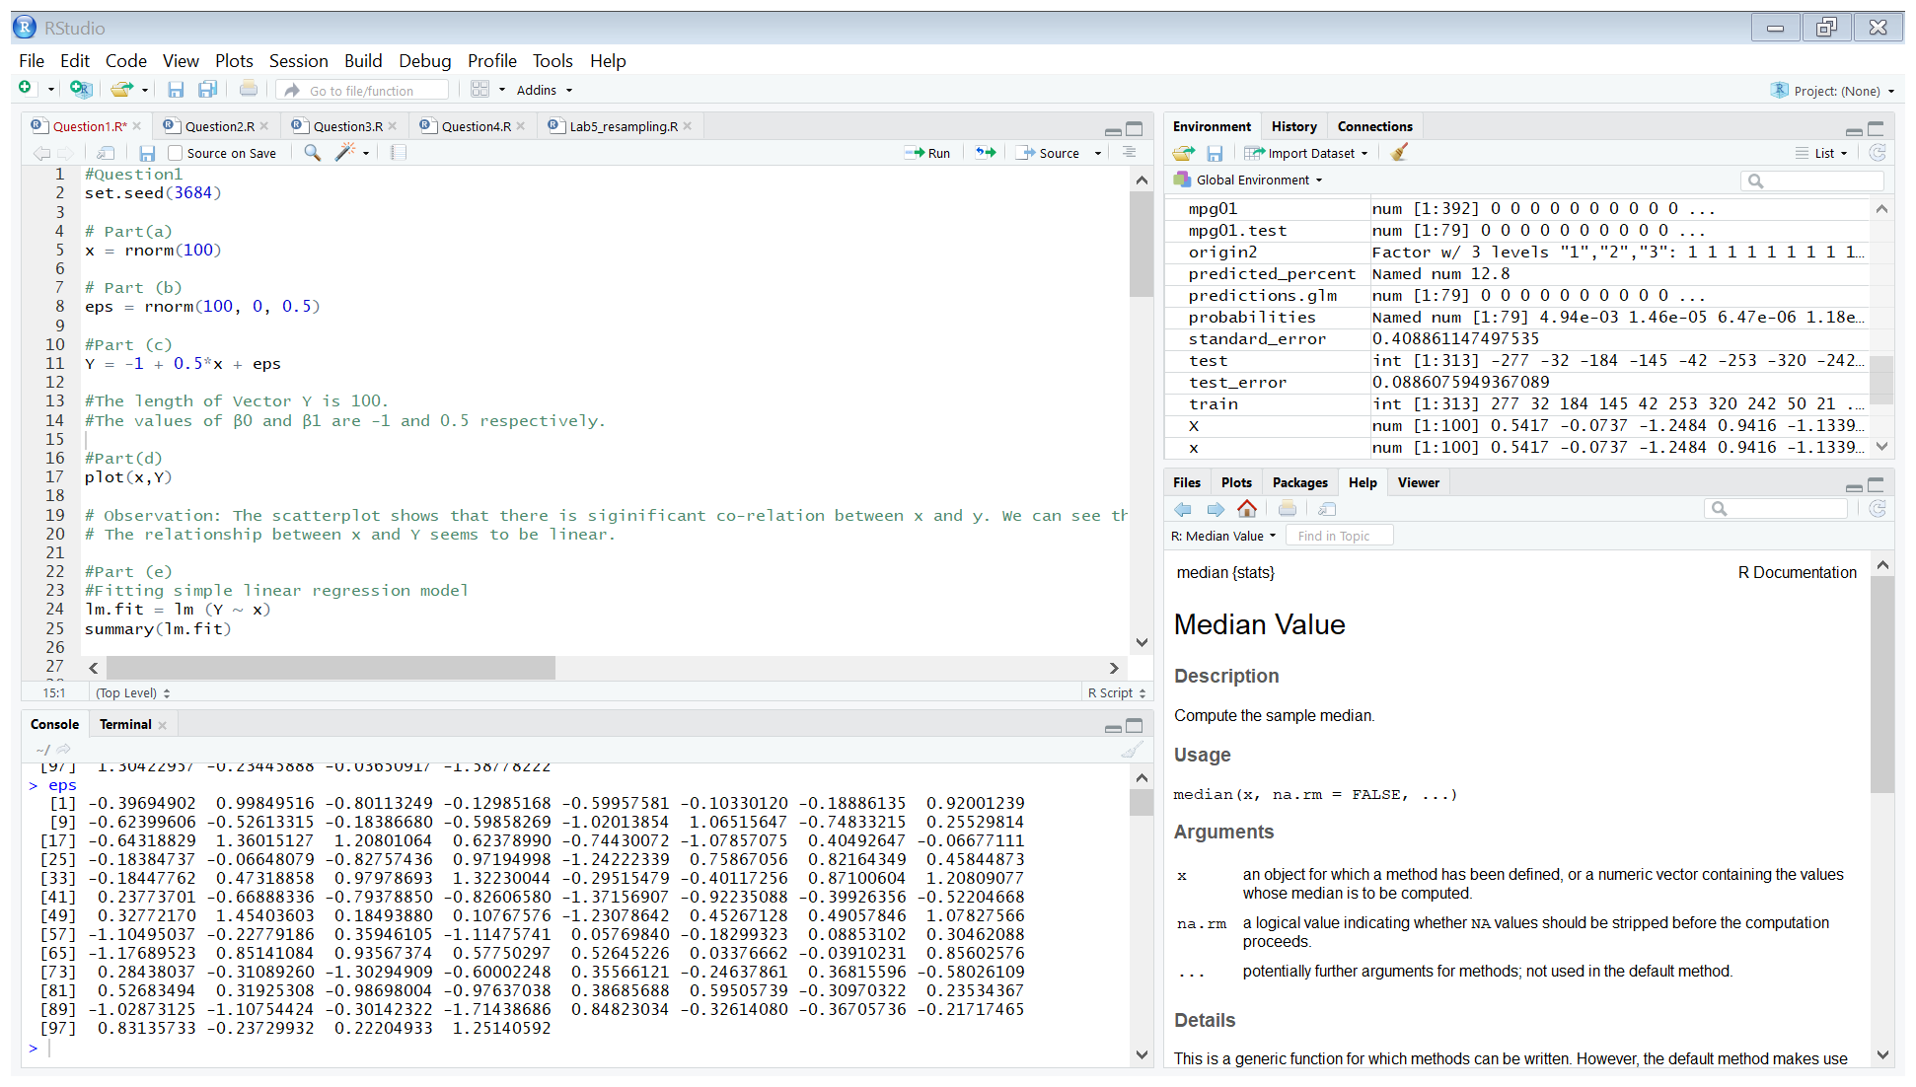

(c)

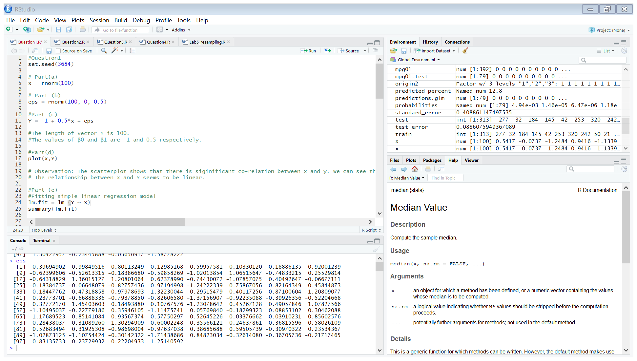

* The length of Vector Y is 100.
* The values of β0 and β1 are -1 and 0.5 respectively.

(d)

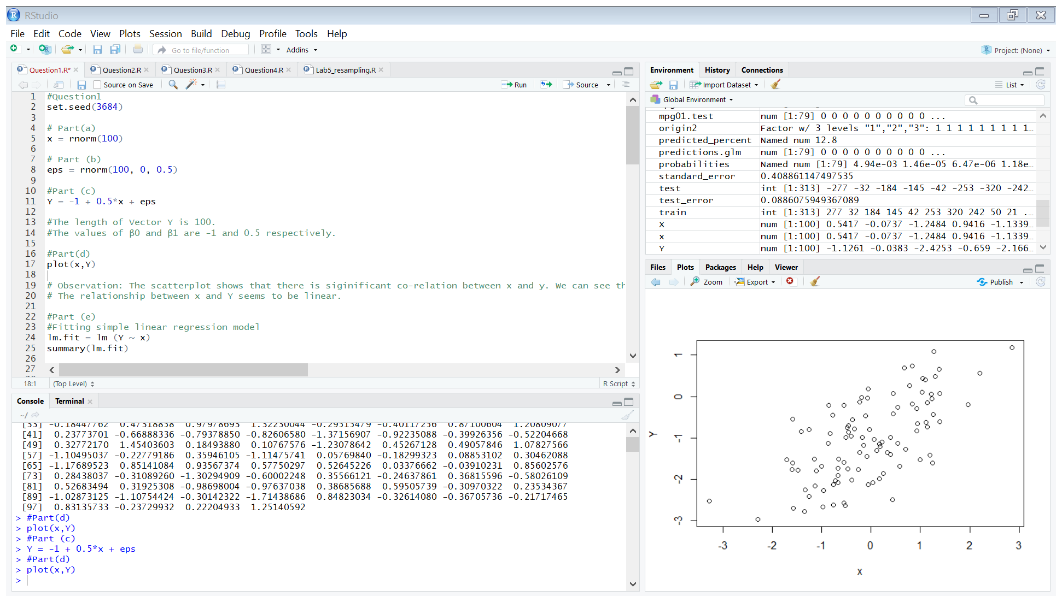

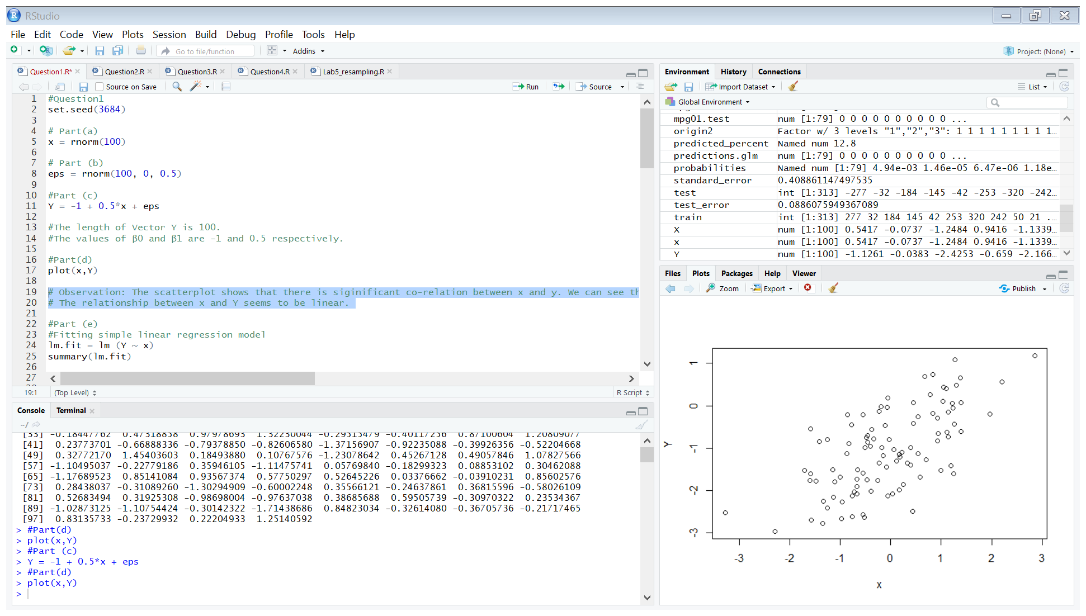

**Observation**: The scatterplot shows that there is significant co-relation between x and y. We can see that the correlation is positive as when x increase, Y also increases. The relationship between x and Y seems to be linear.

(e)

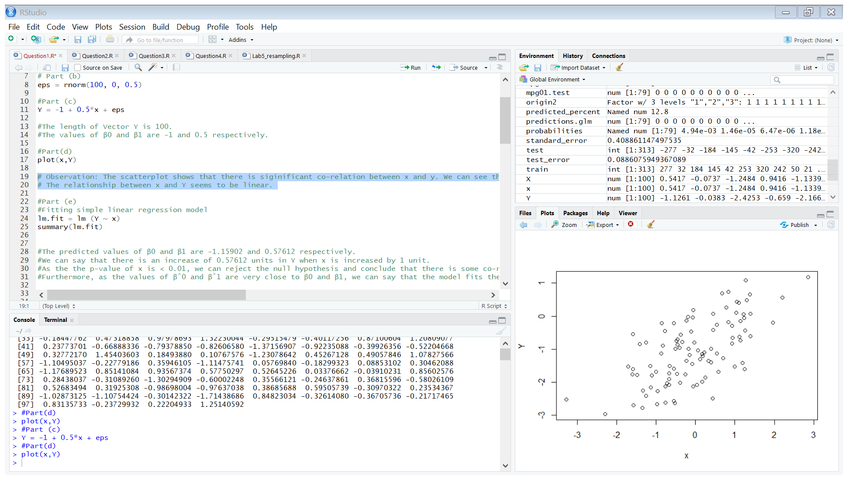

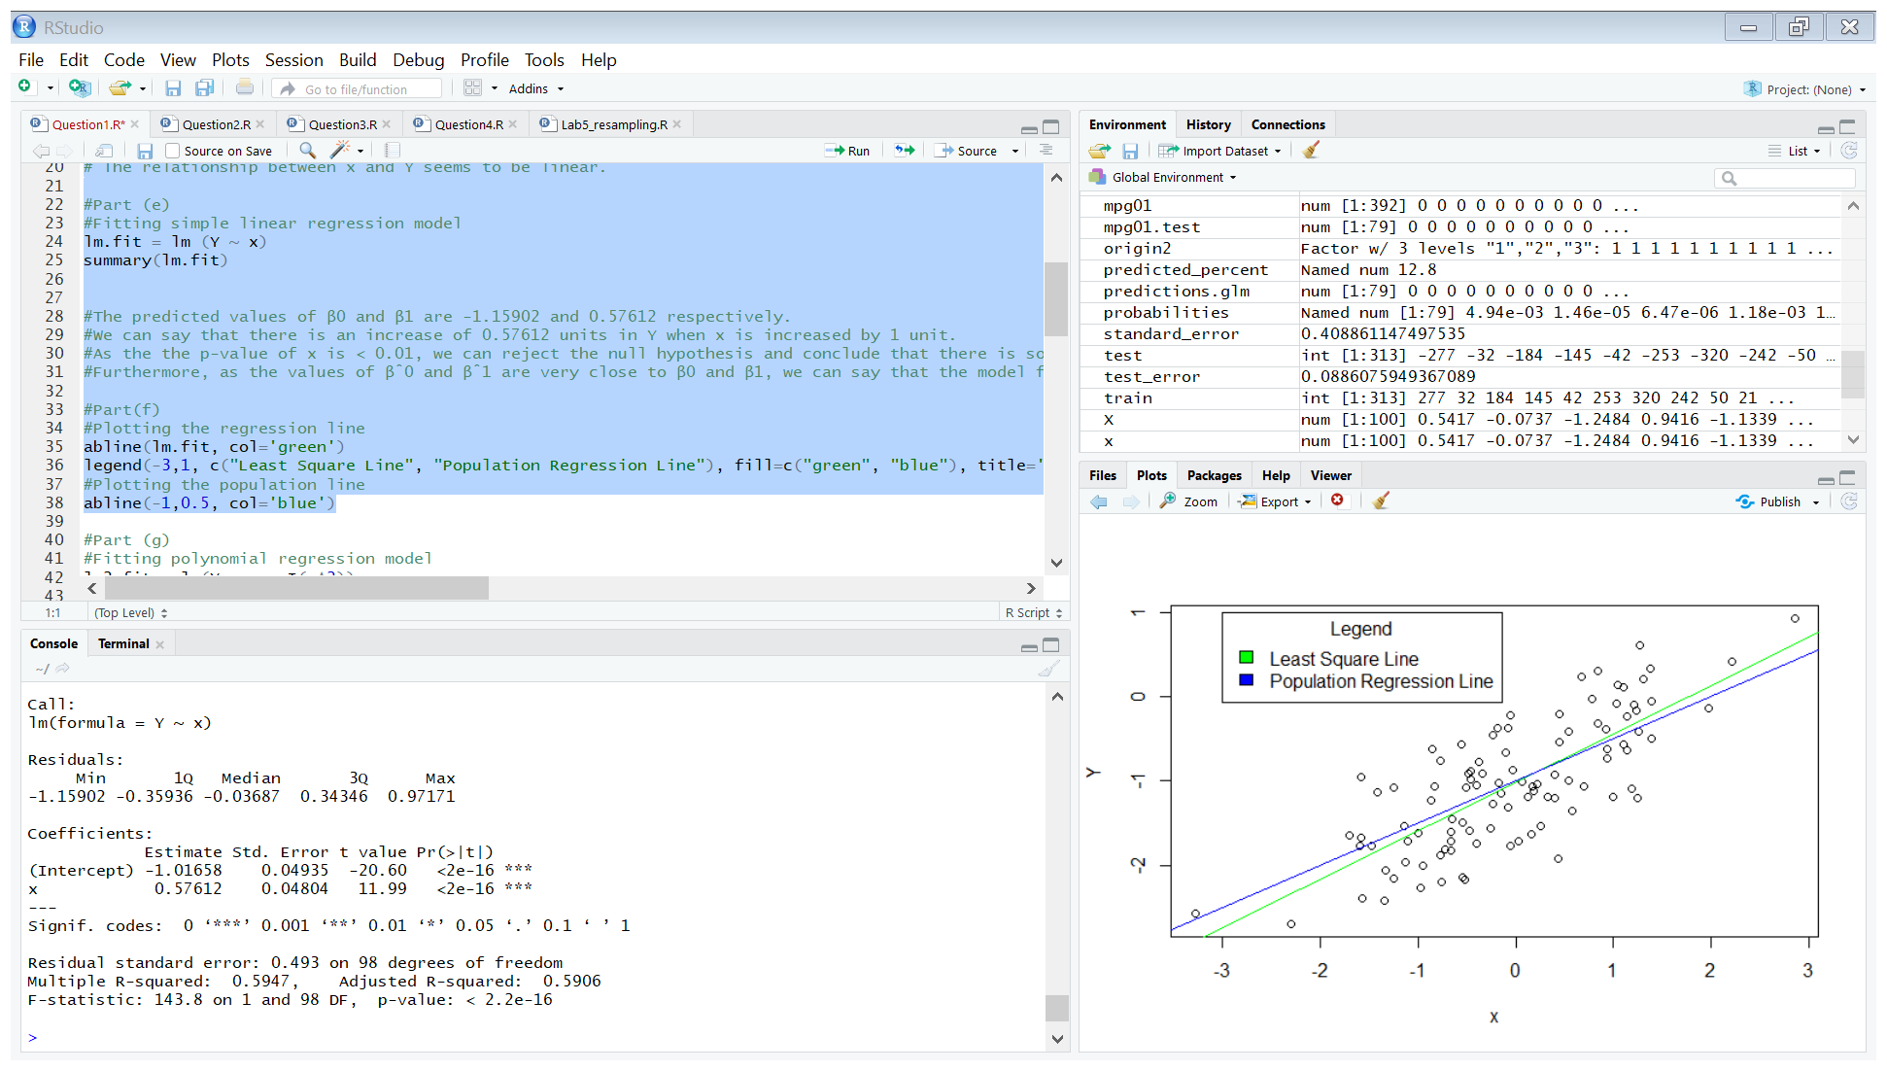

* The predicted values of β0 and β1 are -1.02487 and 0.61418 respectively.
* We can say that there is an increase of 0.61418 units in Y when x is increased by 1 unit.
* As the p-value of x is < 0.01, we can reject the null hypothesis and conclude that there is some co-relation between x and Y.
* Furthermore, as the values of βˆ0 and βˆ1 are very close to β0 and β1, we can say that the model fits the data well.

(f)

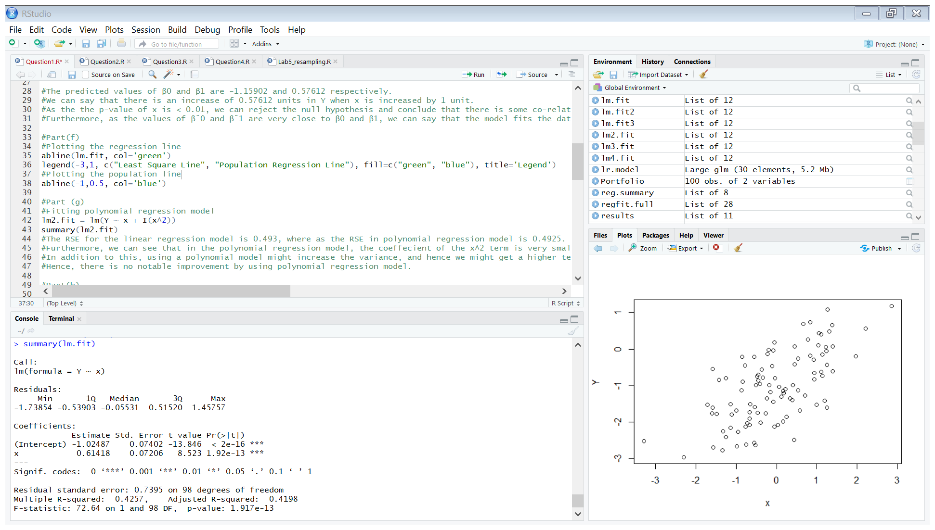

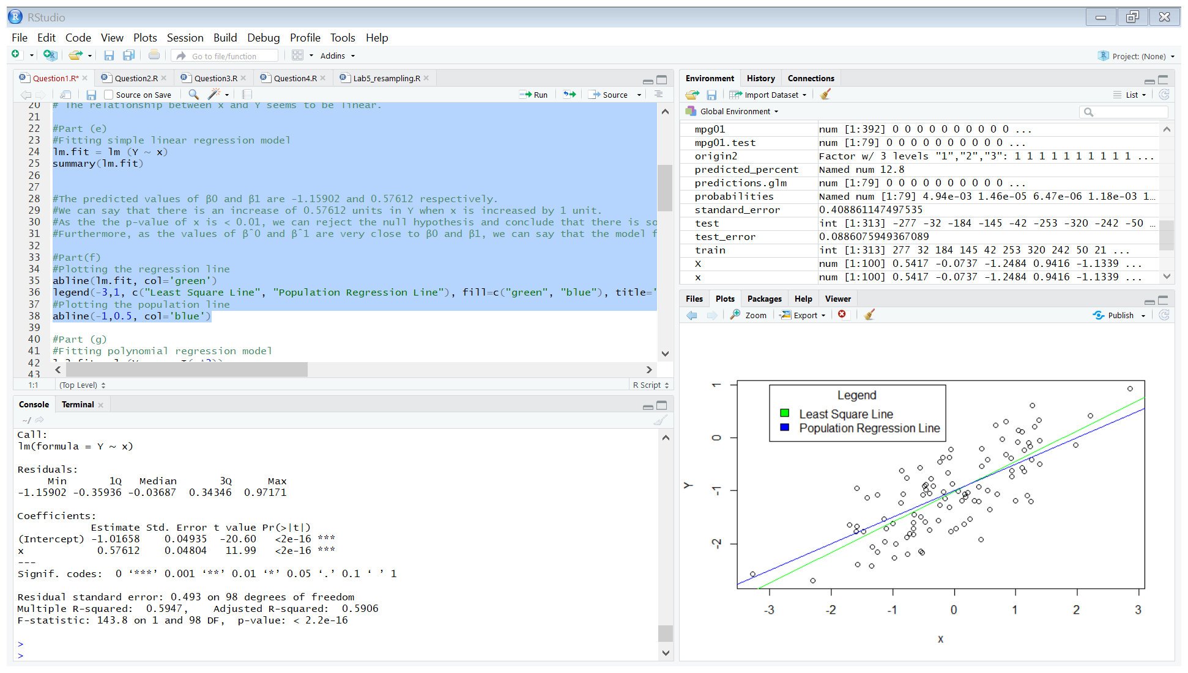

(g)

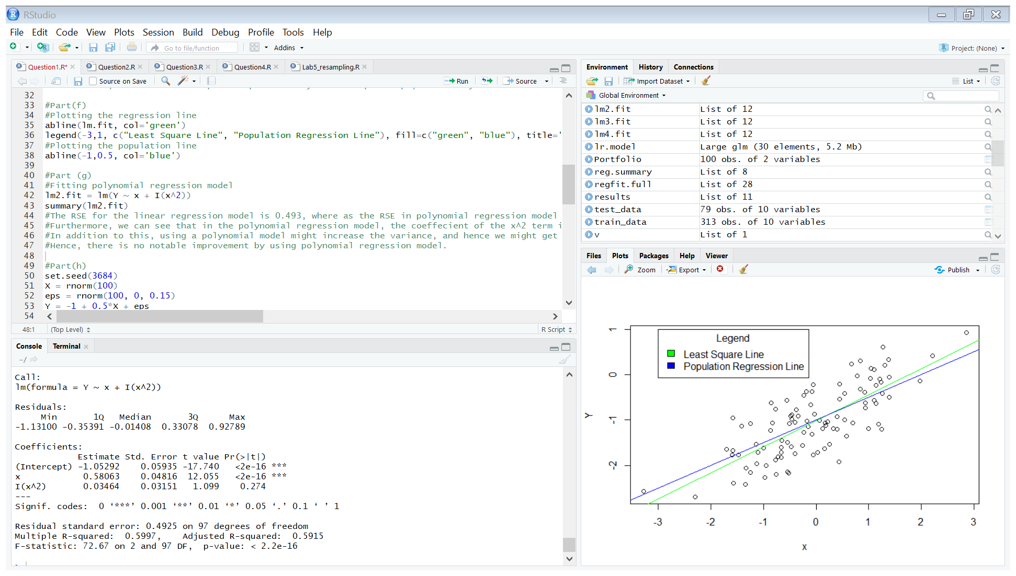

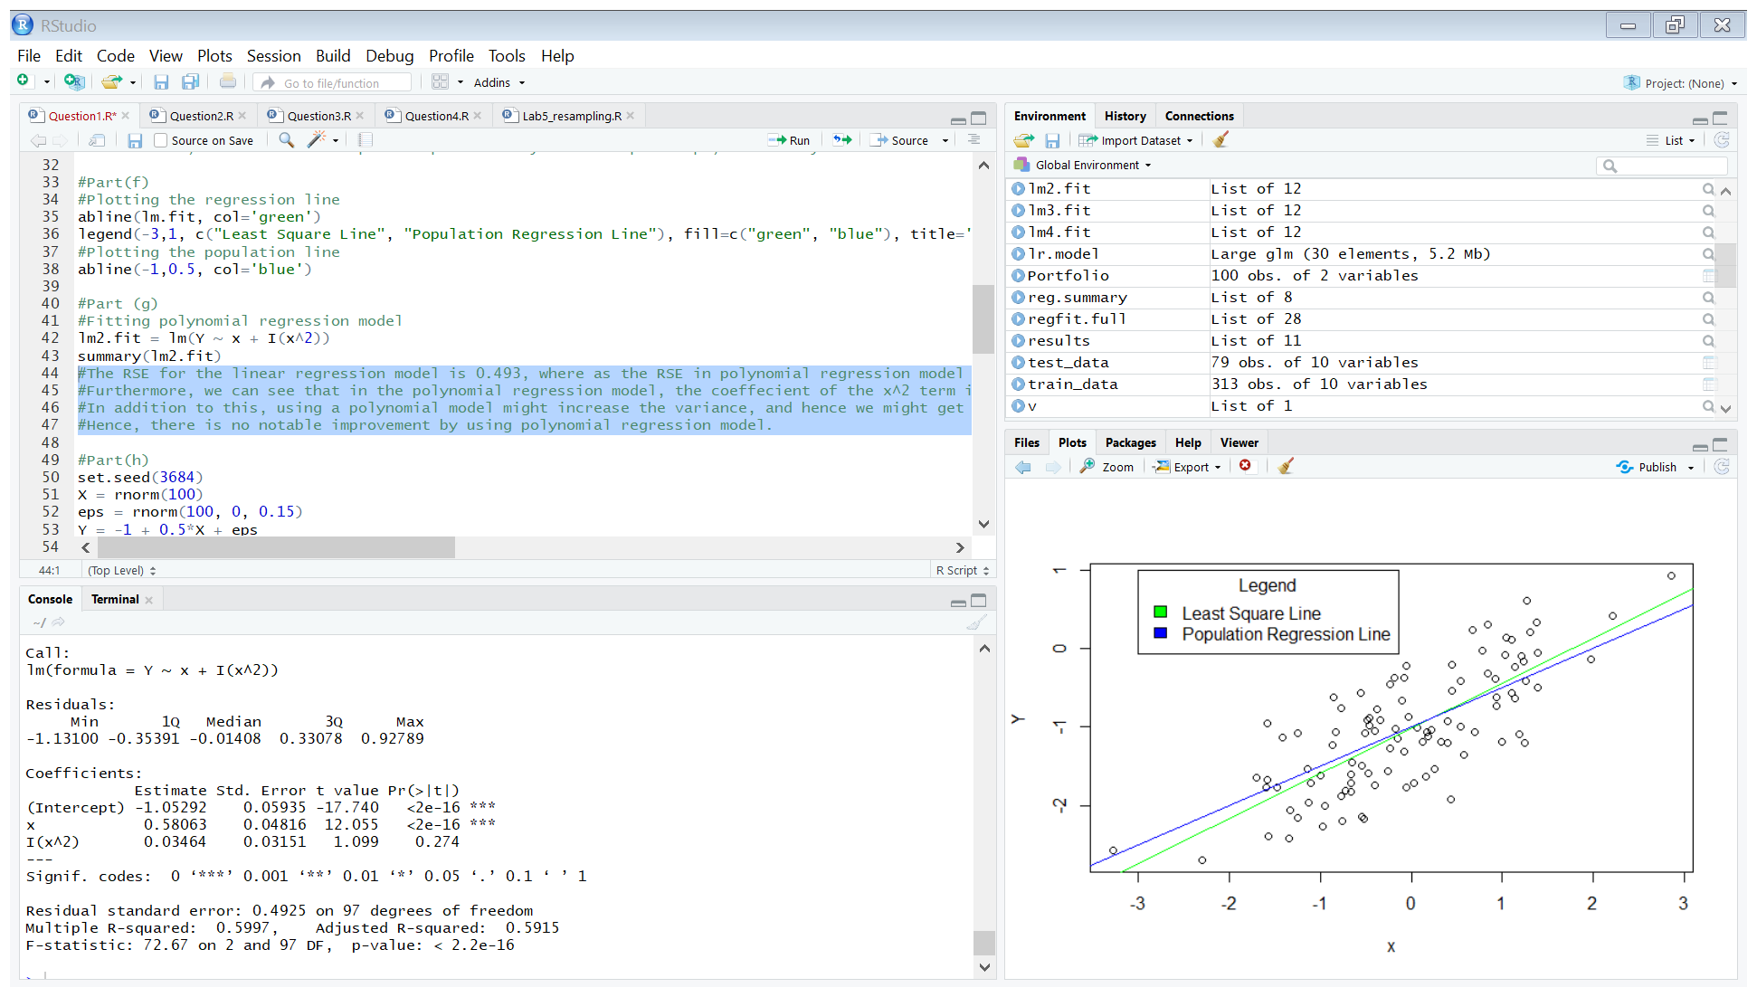

* The RSE for the linear regression model is 0.493, where as the RSE in polynomial regression model is 0.4925. Since there is not a significant difference in the RSE, the quadratic term improves the model only minutely.
* Furthermore, we can see that in the polynomial regression model, the coefficient of the x^2 term is very small compared to the coefficient of x, as the relationship between x and Y is mainly linear.
* In addition to this, using a polynomial model might increase the variance, and hence we might get a higher test error.
* Hence, there is no notable improvement by using polynomial regression model.

(h)

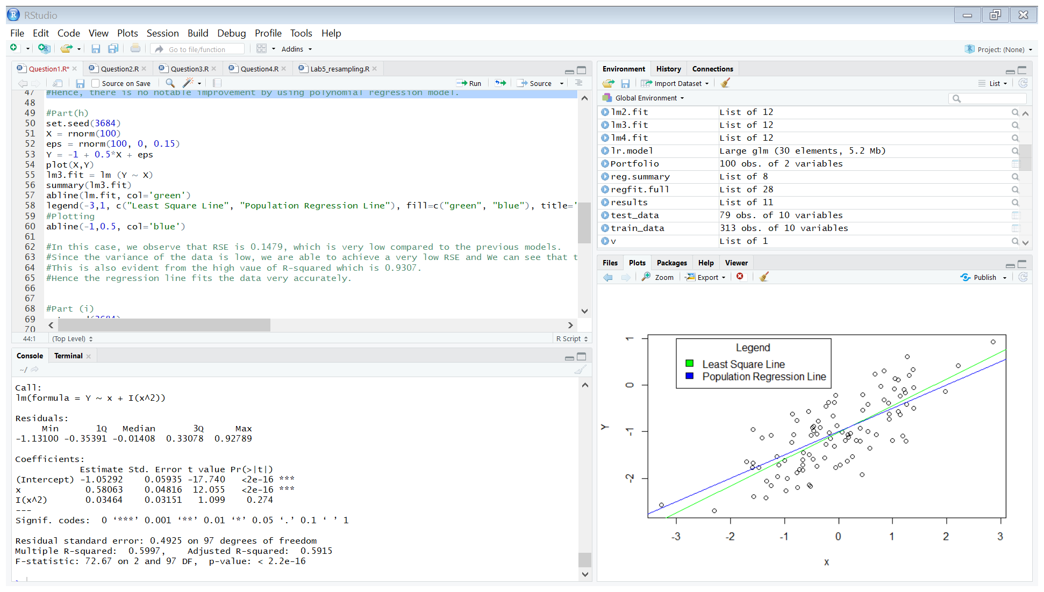

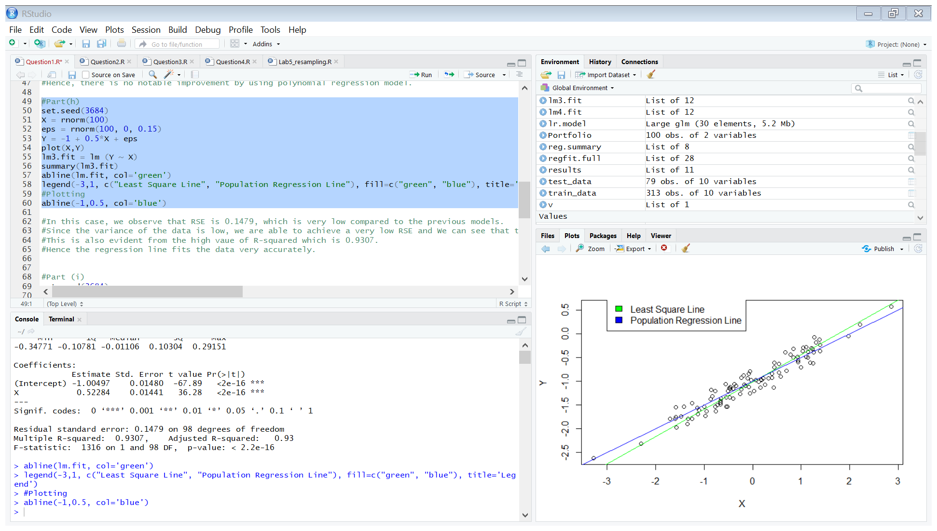

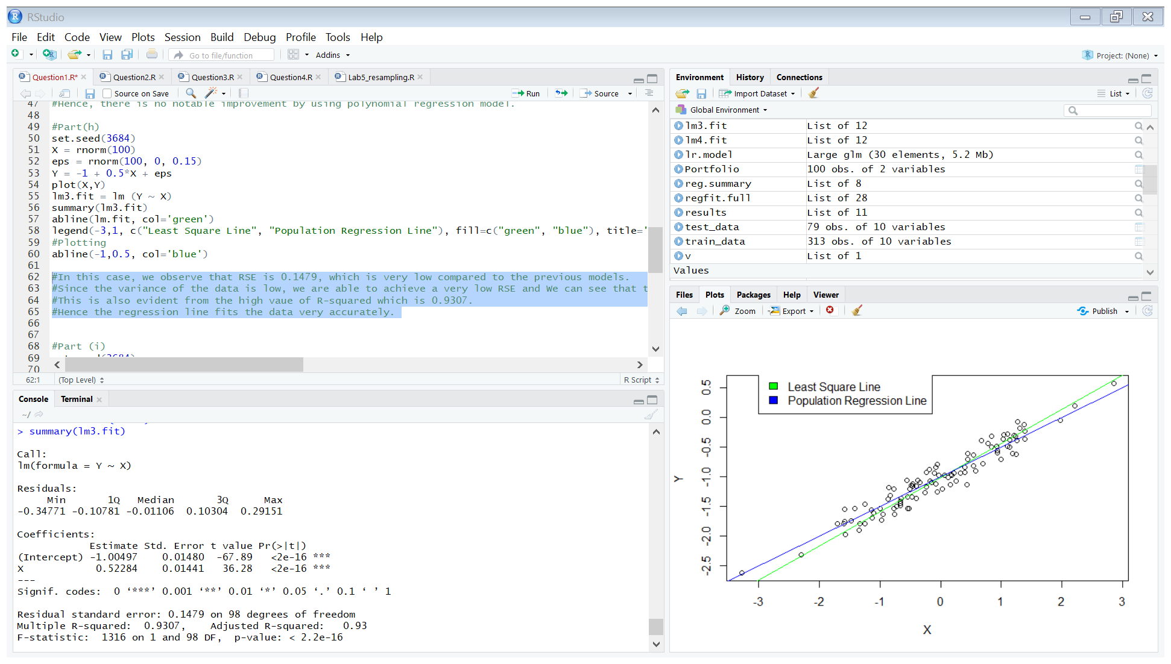

* In this case, we observe that RSE is 0.1479, which is very low compared to the previous models.
* Since the variance of the data is low, we are able to achieve a very low RSE and We can see that the regression line is very close to the population line and they are almost overlapping.
* This is also evident from the high value of R-squared which is 0.9307.
* Hence the regression line fits the data very accurately.

(i)

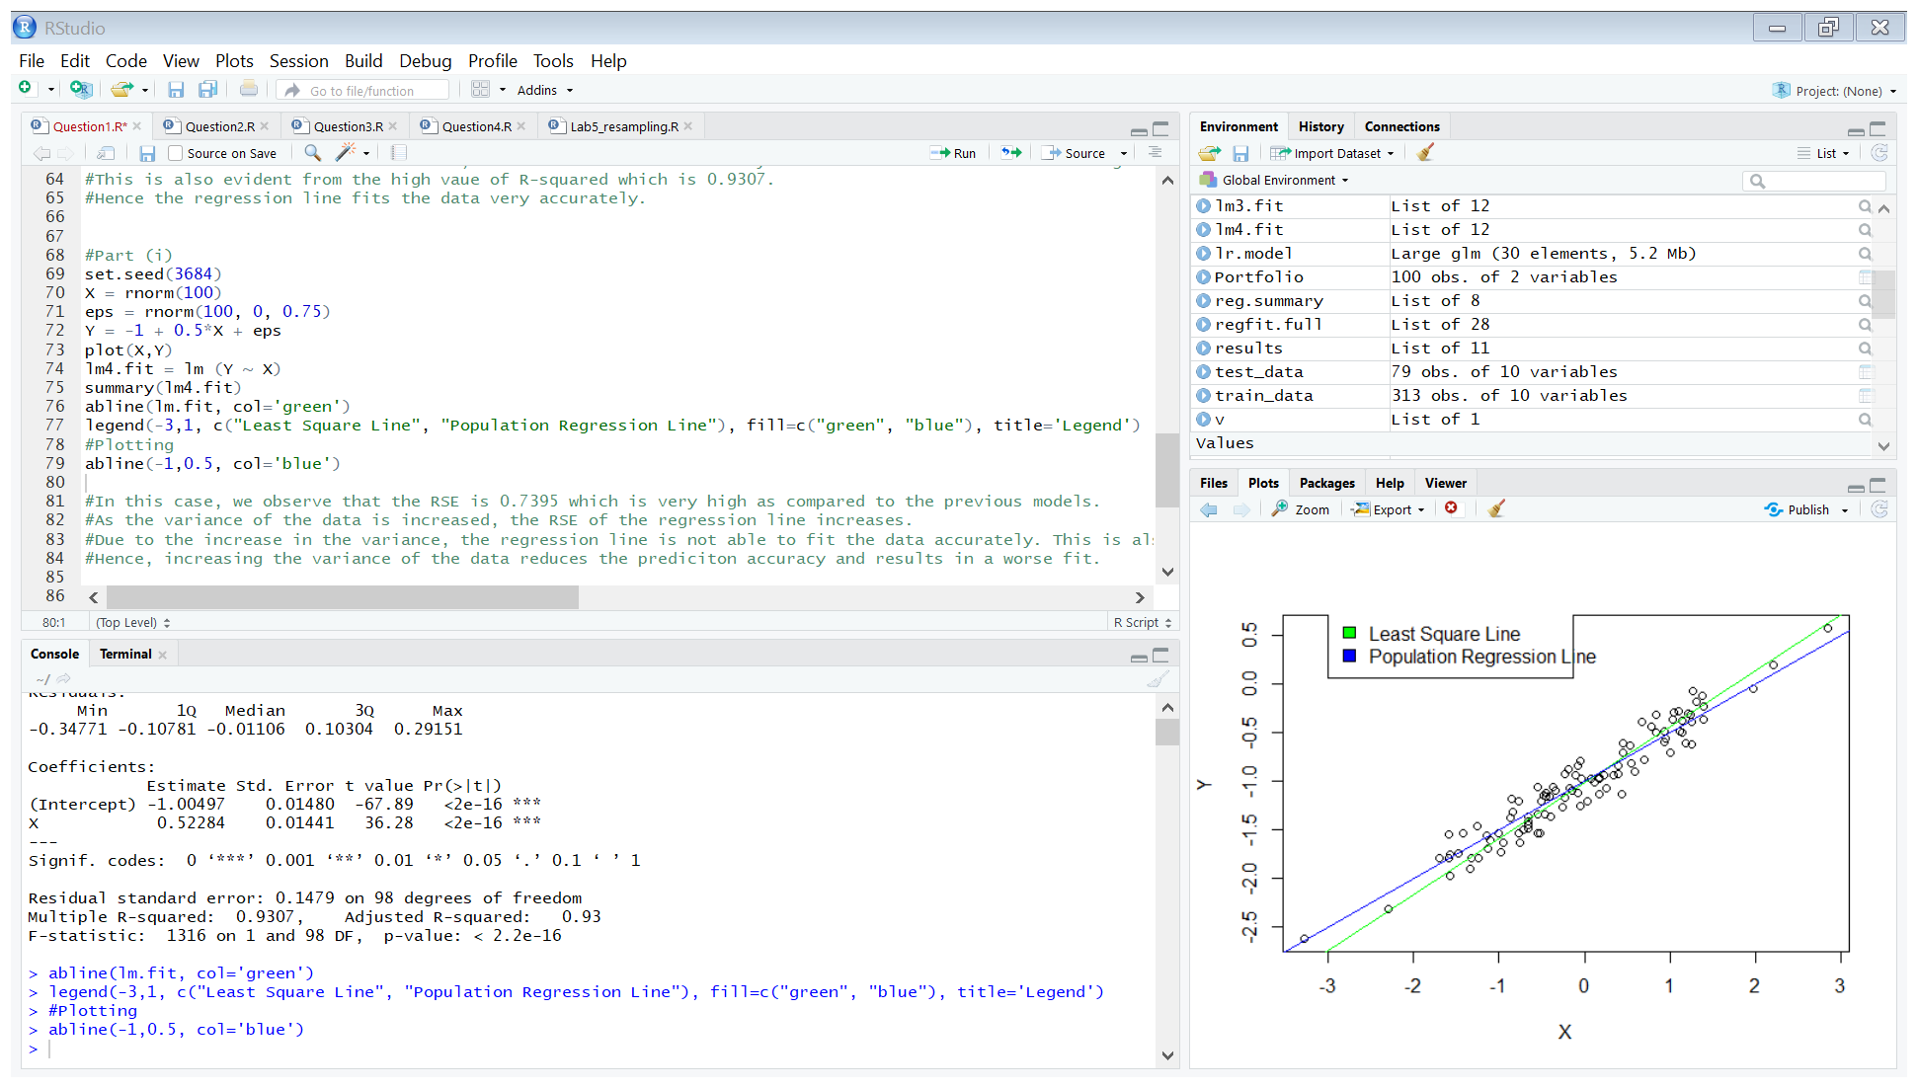

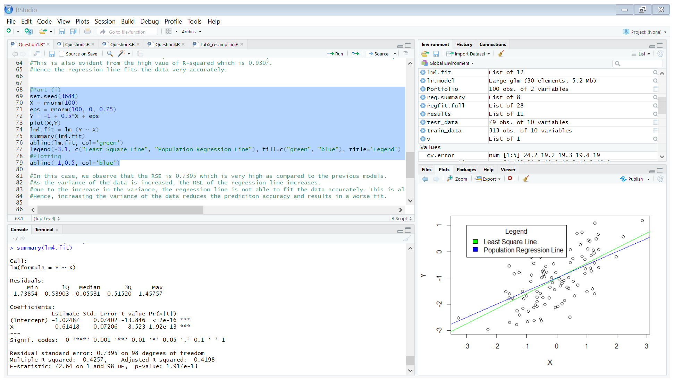

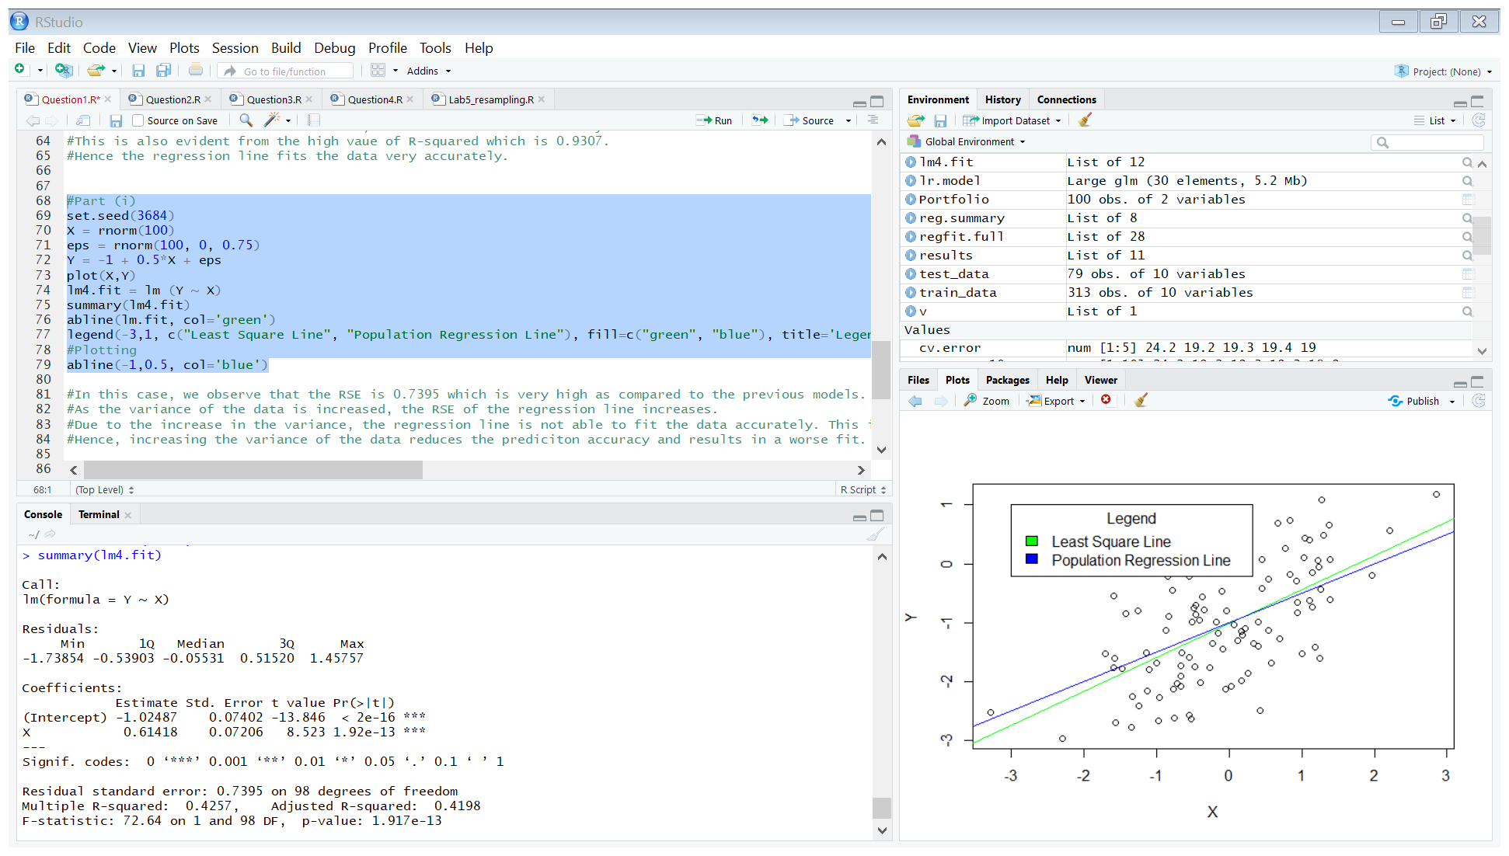

* In this case, we observe that the RSE is 0.7395 which is very high as compared to the previous models.
* As the variance of the data is increased, the RSE of the regression line increases.
* Due to the increase in the variance, the regression line is not able to fit the data accurately. This is also evident from the low R-squared value which is 0.4257.
* Hence, increasing the variance of the data reduces the prediction accuracy and results in a worse fit.

(j)

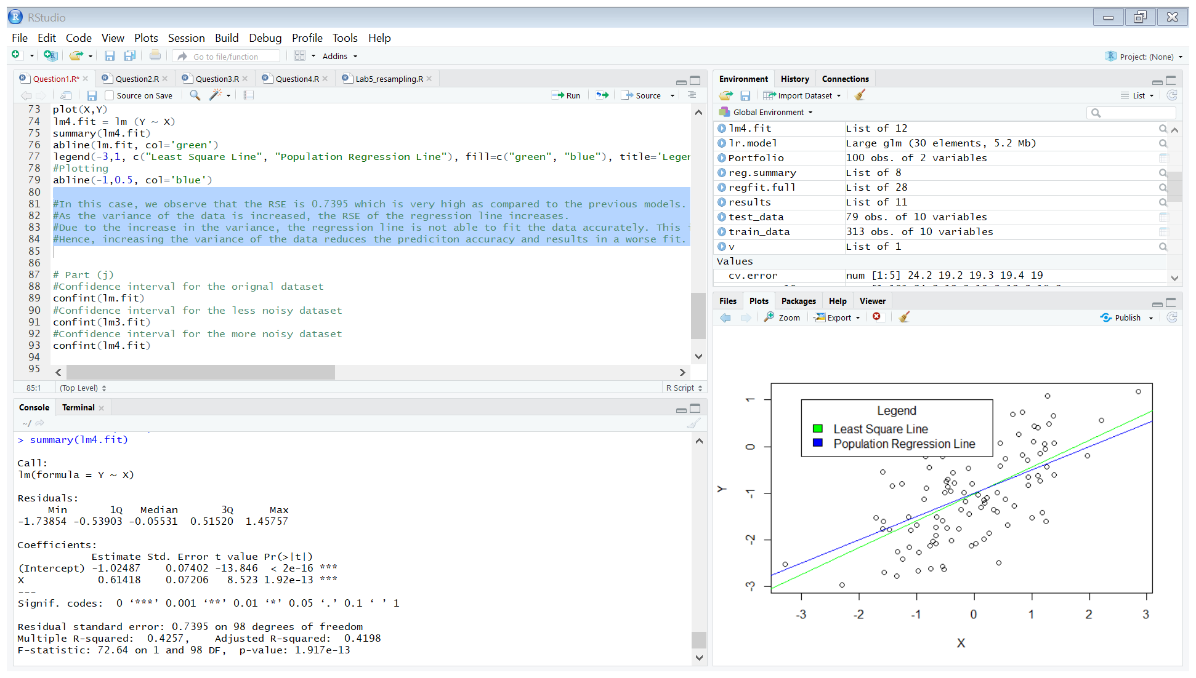

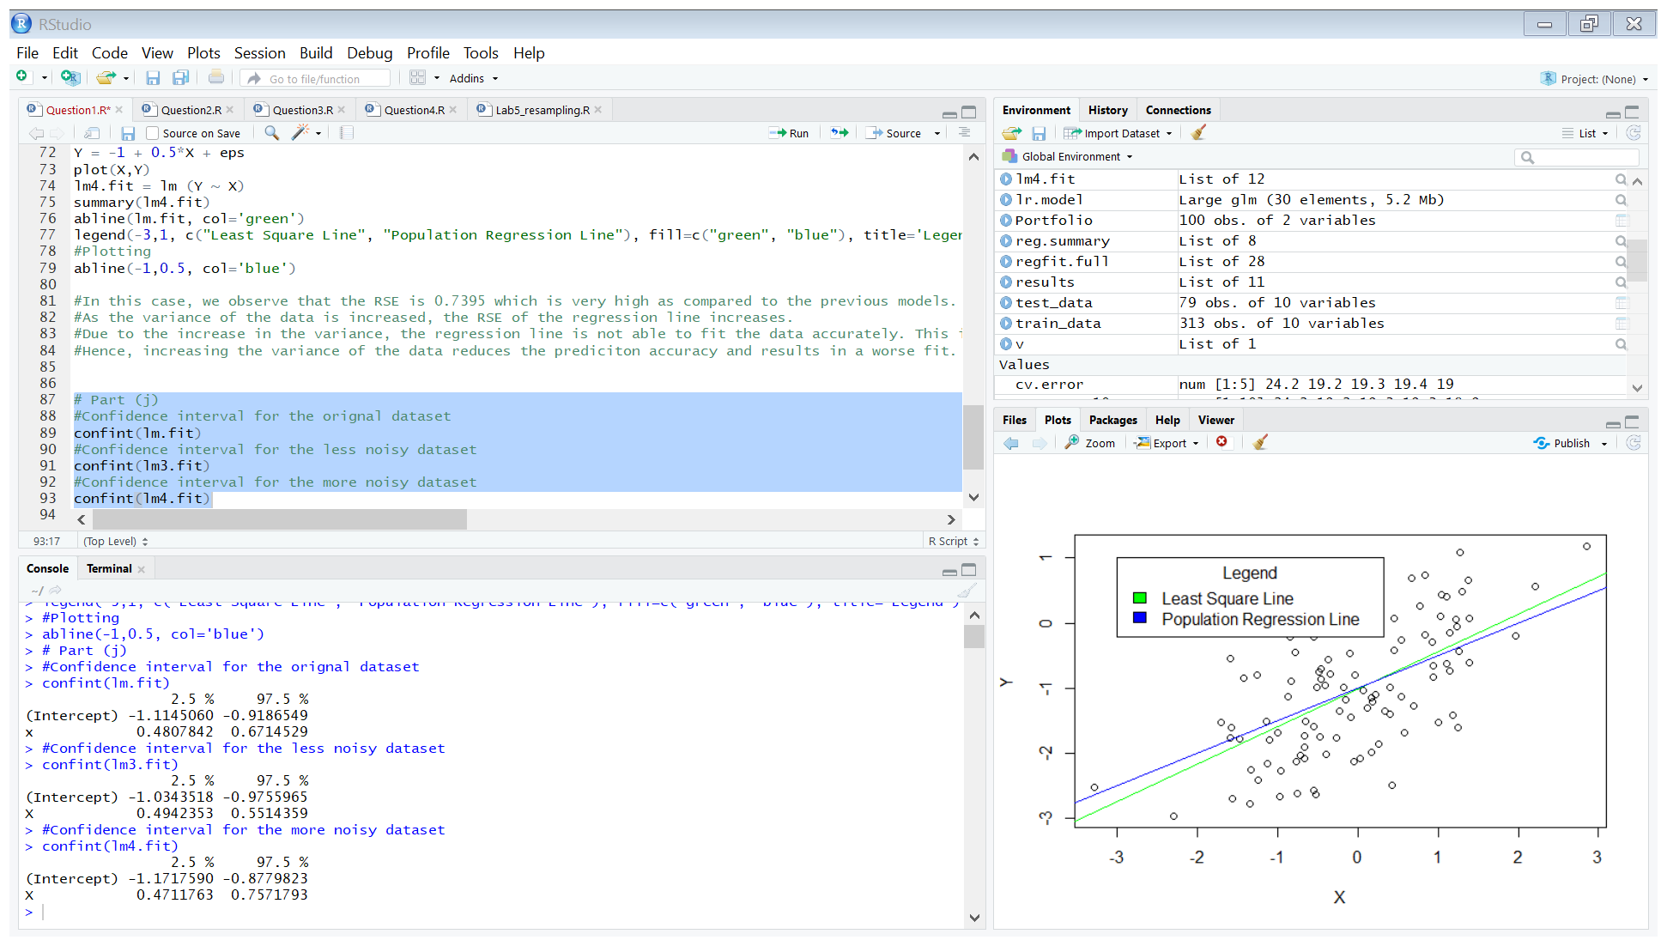

* We observe that in case of the less noisy dataset, the width of the confidence interval decreases as compared to the original dataset, hence we can be more certain about the predict the values of β0 and β1.
* We observe that in case of the noisier dataset, the width of the confidence interval increases as compared to the original dataset, hence we are less certain about the predict the values of β0 and β1.

**Question 2.**

**(a)**

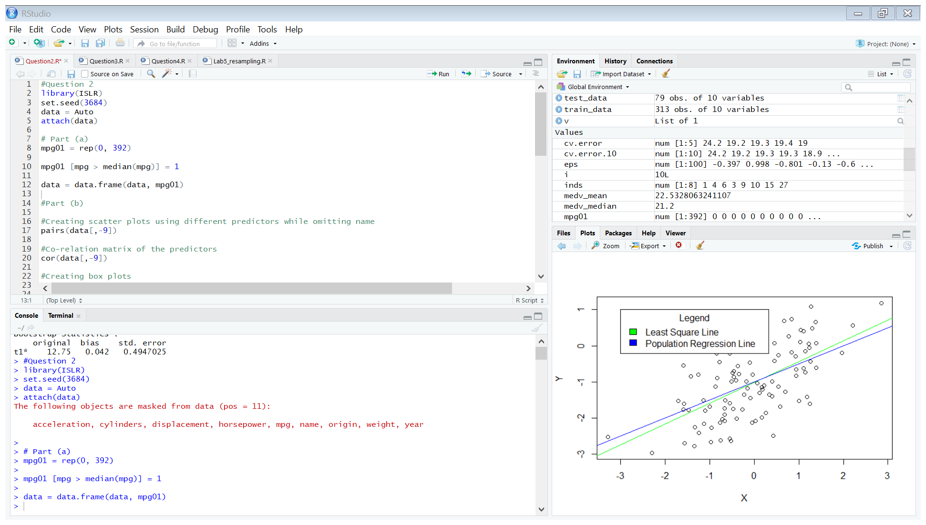

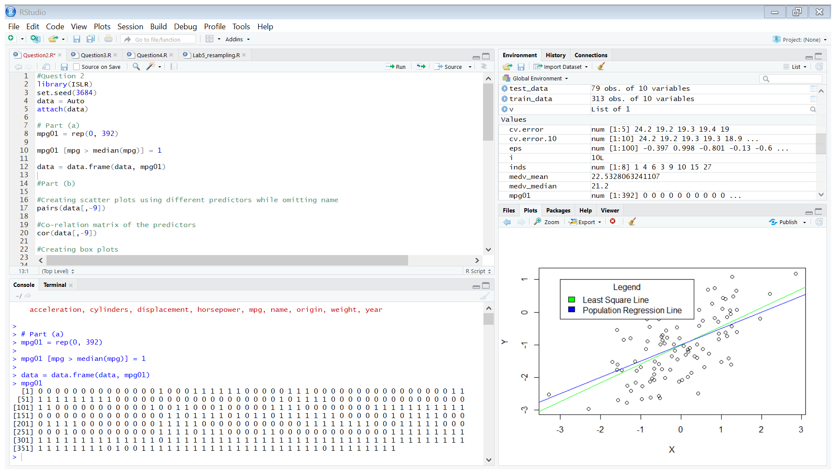

**(b)**

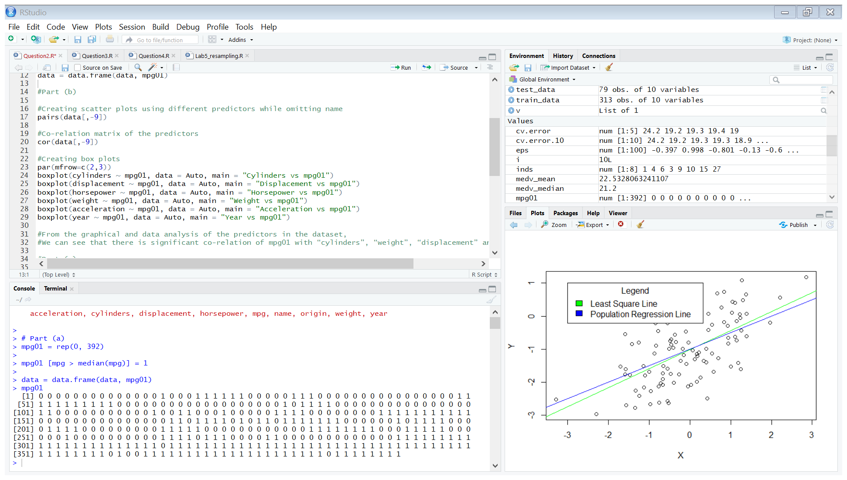

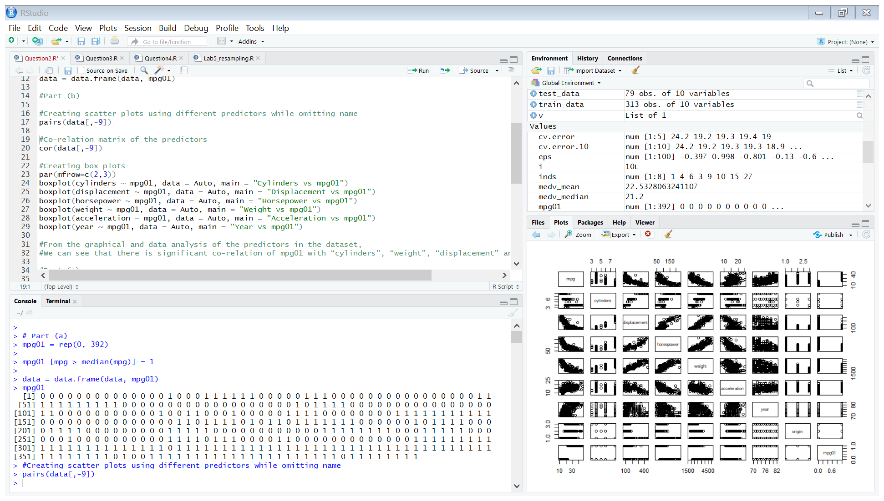

**Scatterplots**

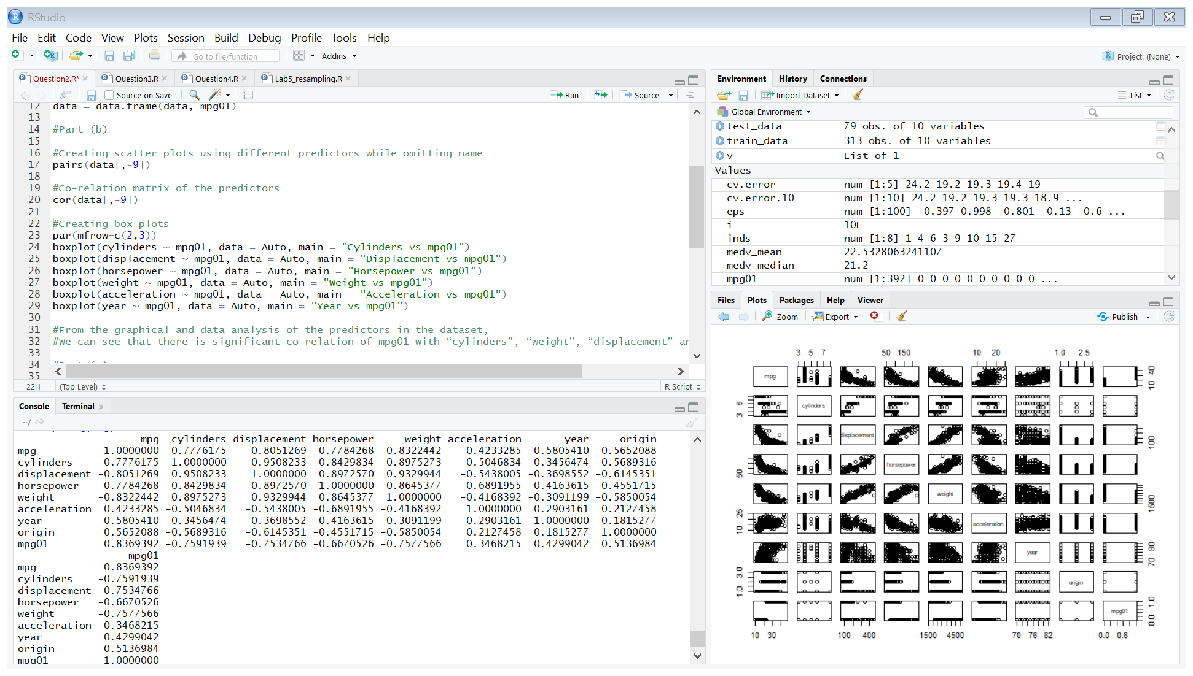

**Correlation Matrix**

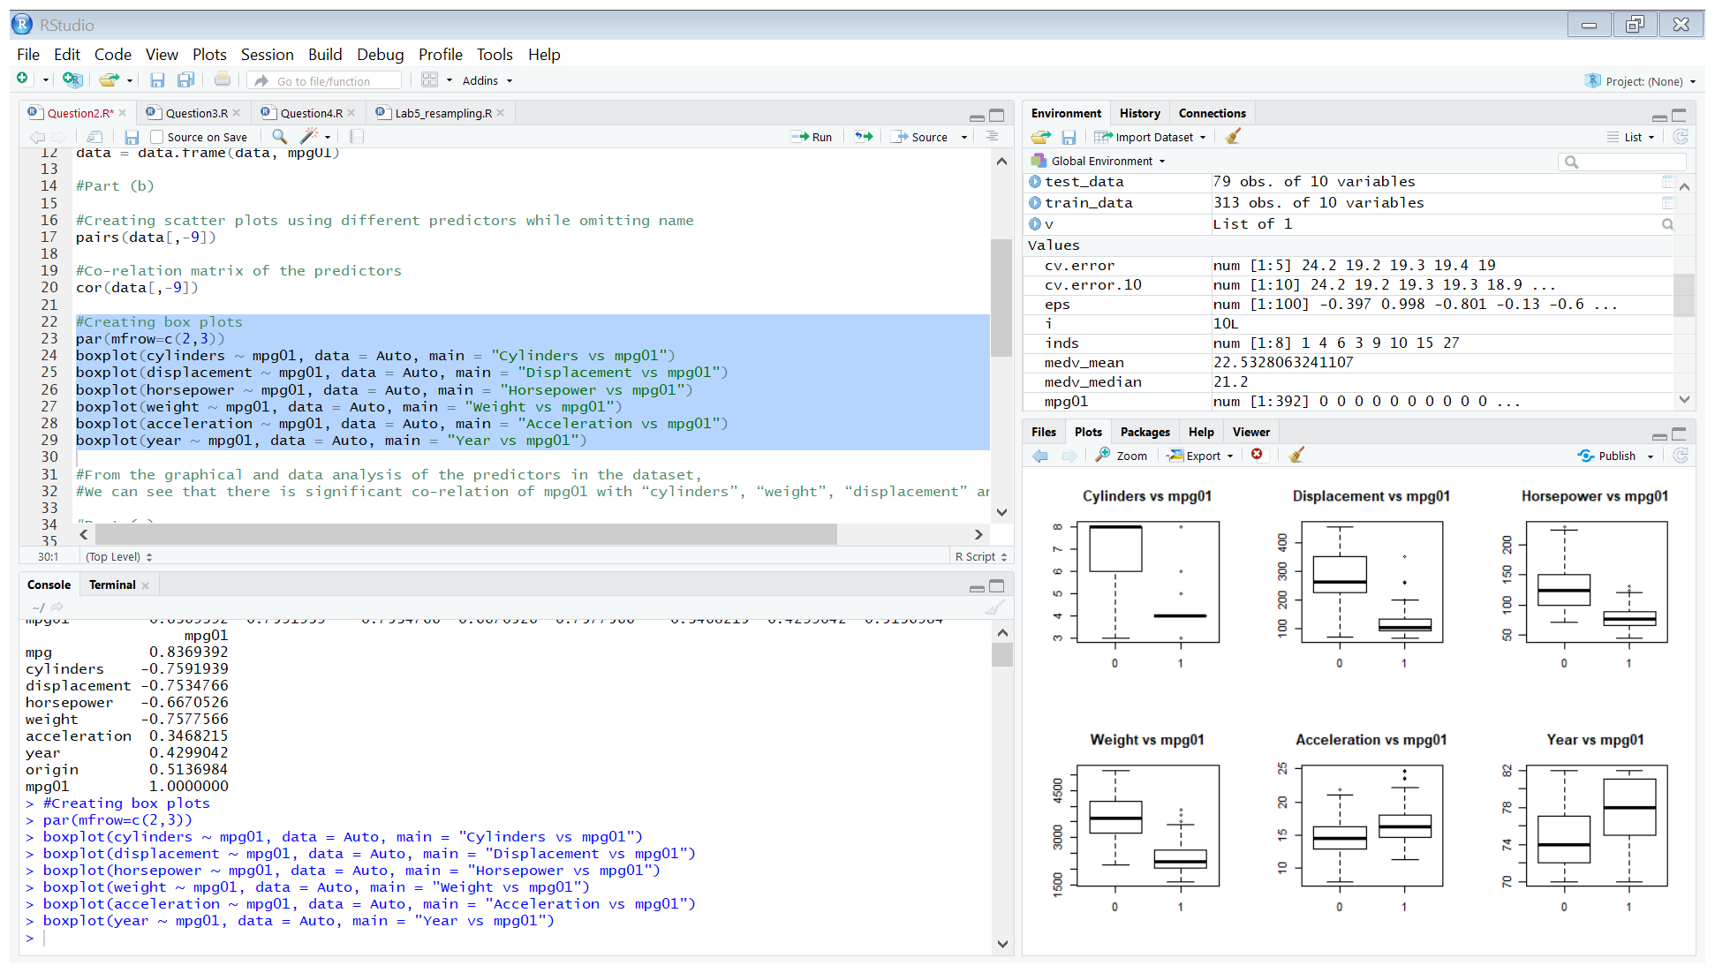

**Boxplots**

* From the graphical and data analysis of the predictors in the dataset,
* We can see that there is significant co-relation of mpg01 with “cylinders”, “weight”, “displacement” and “horsepower”.

**(c)**

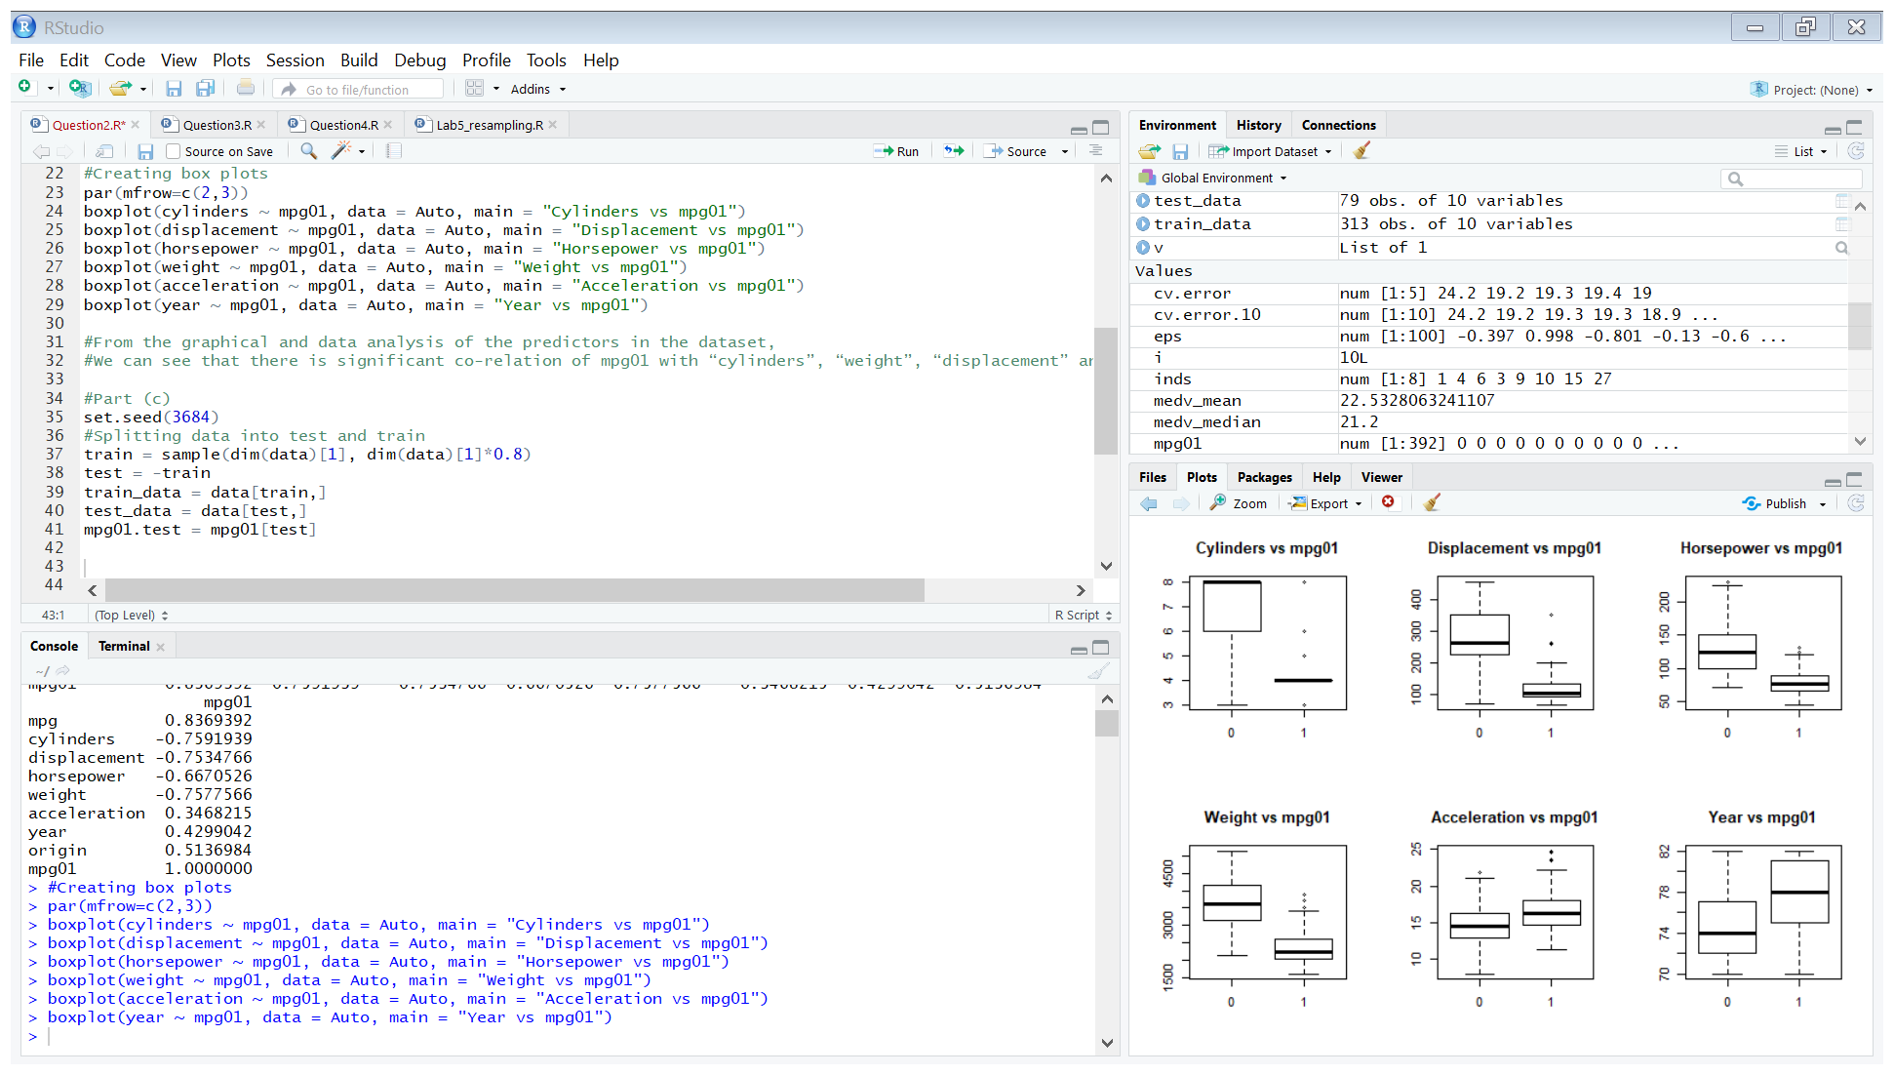

* We have split the dataset into training and testing dataset based on the 80:20 ratio.

**(d)**

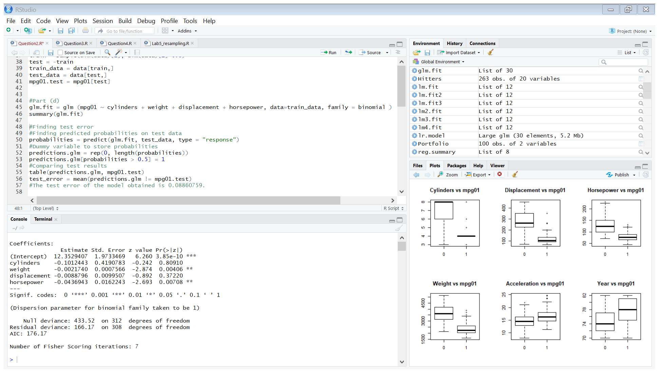

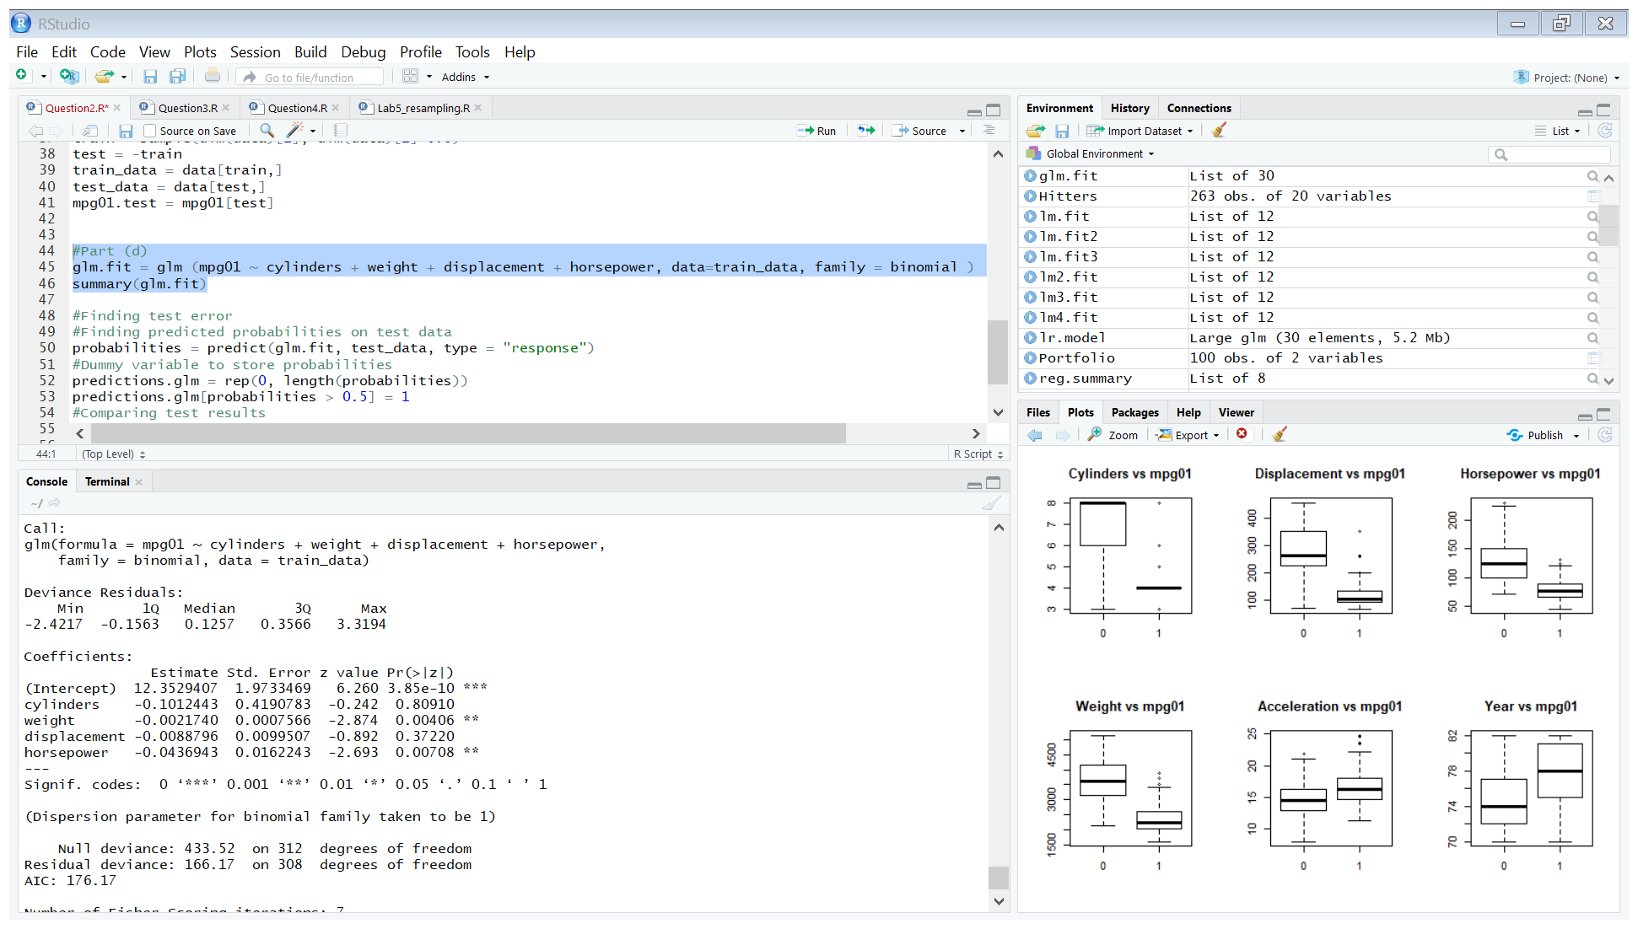

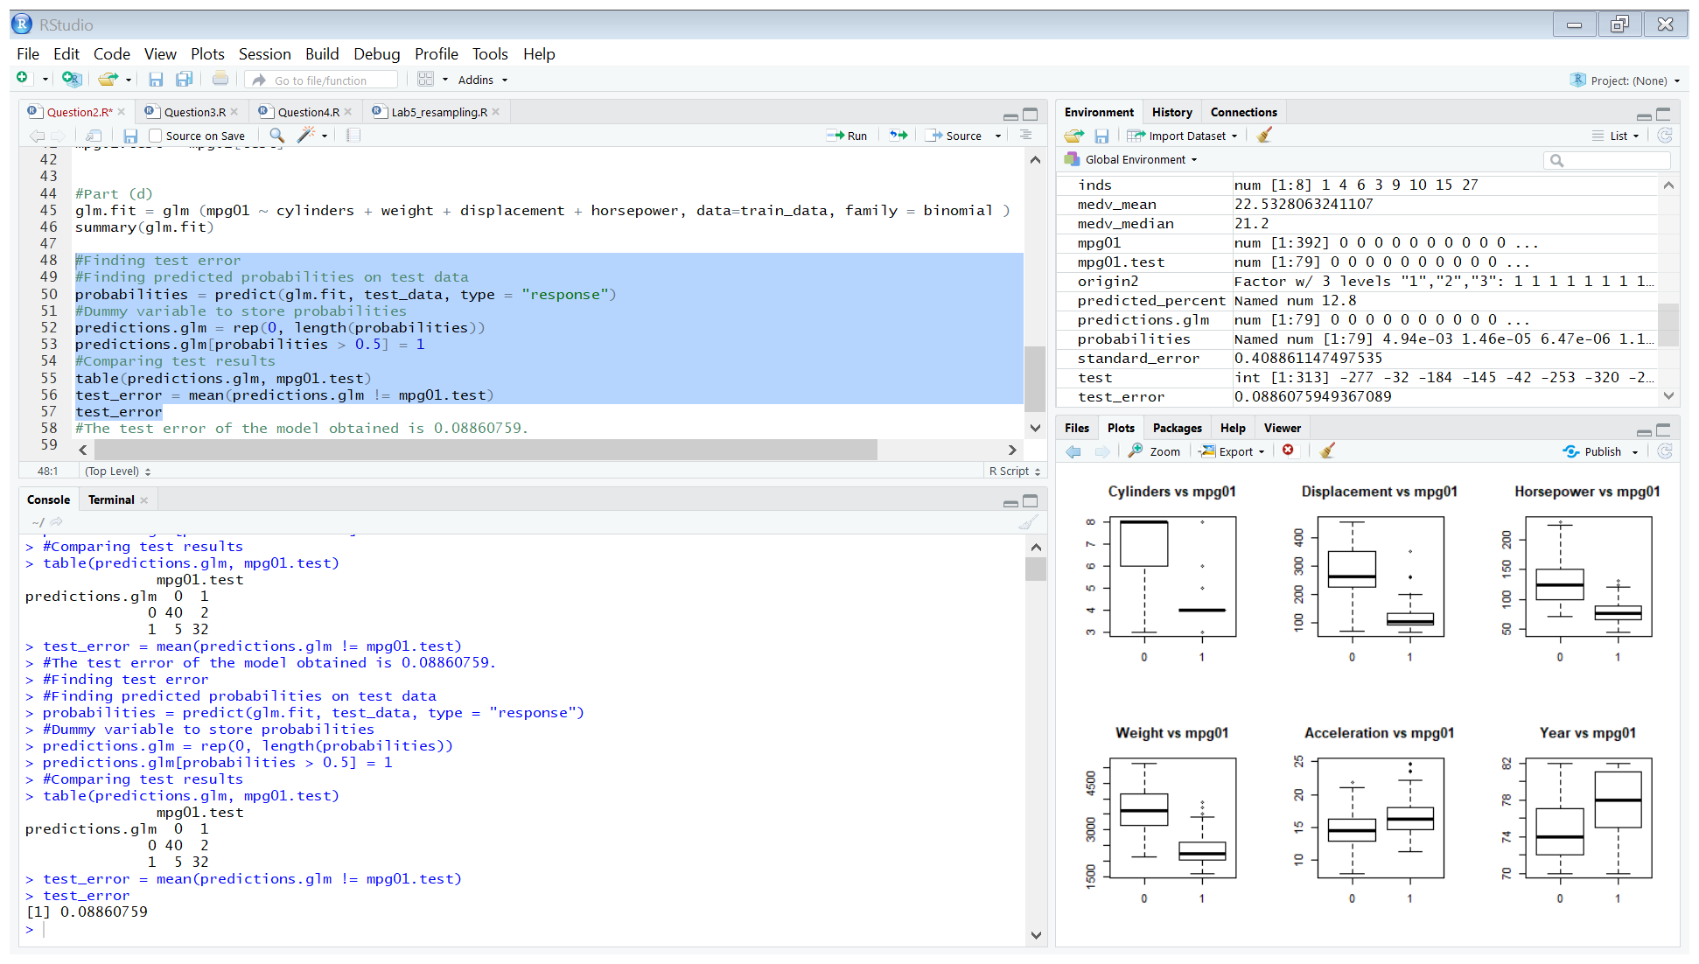

* The test-error rate obtained is 8.860759%.

**Question 3.**

**(a)**

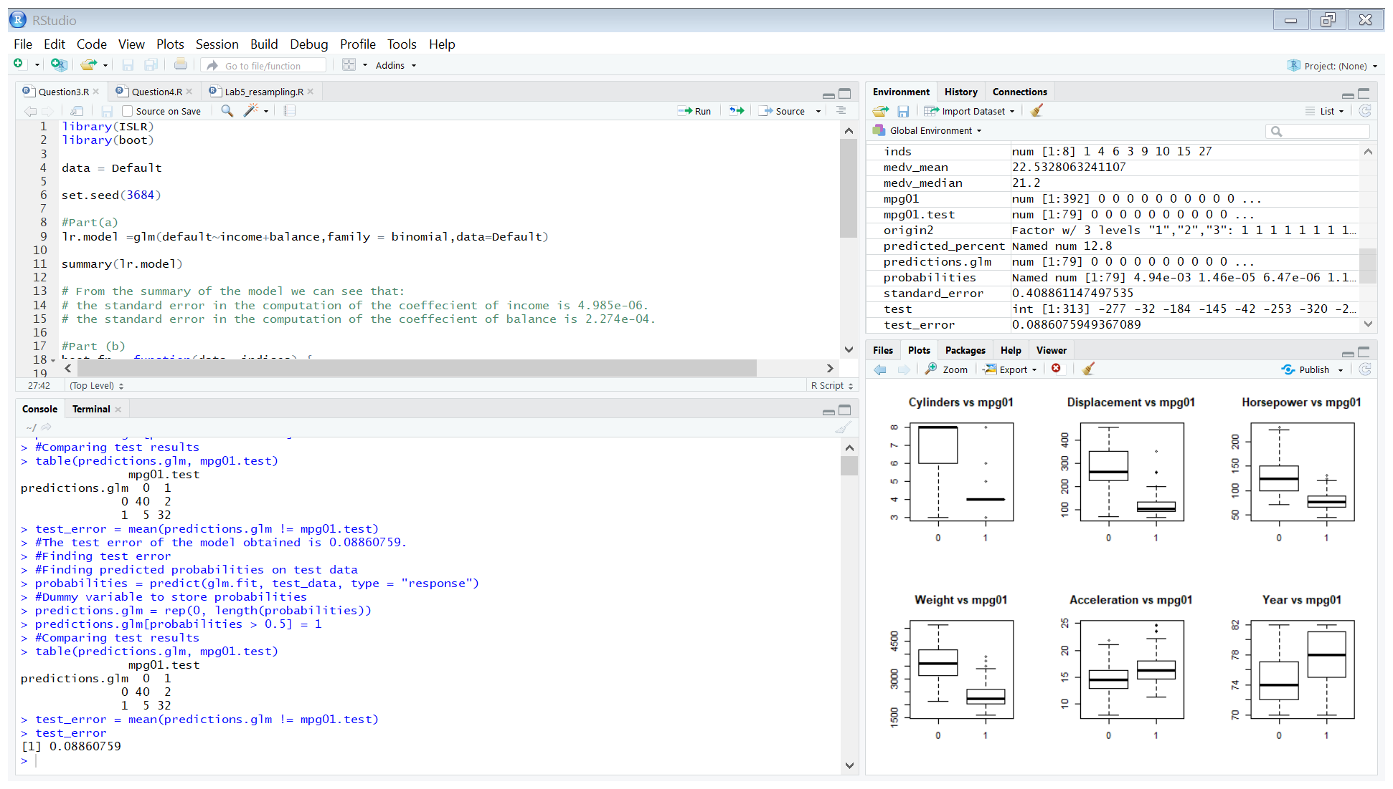

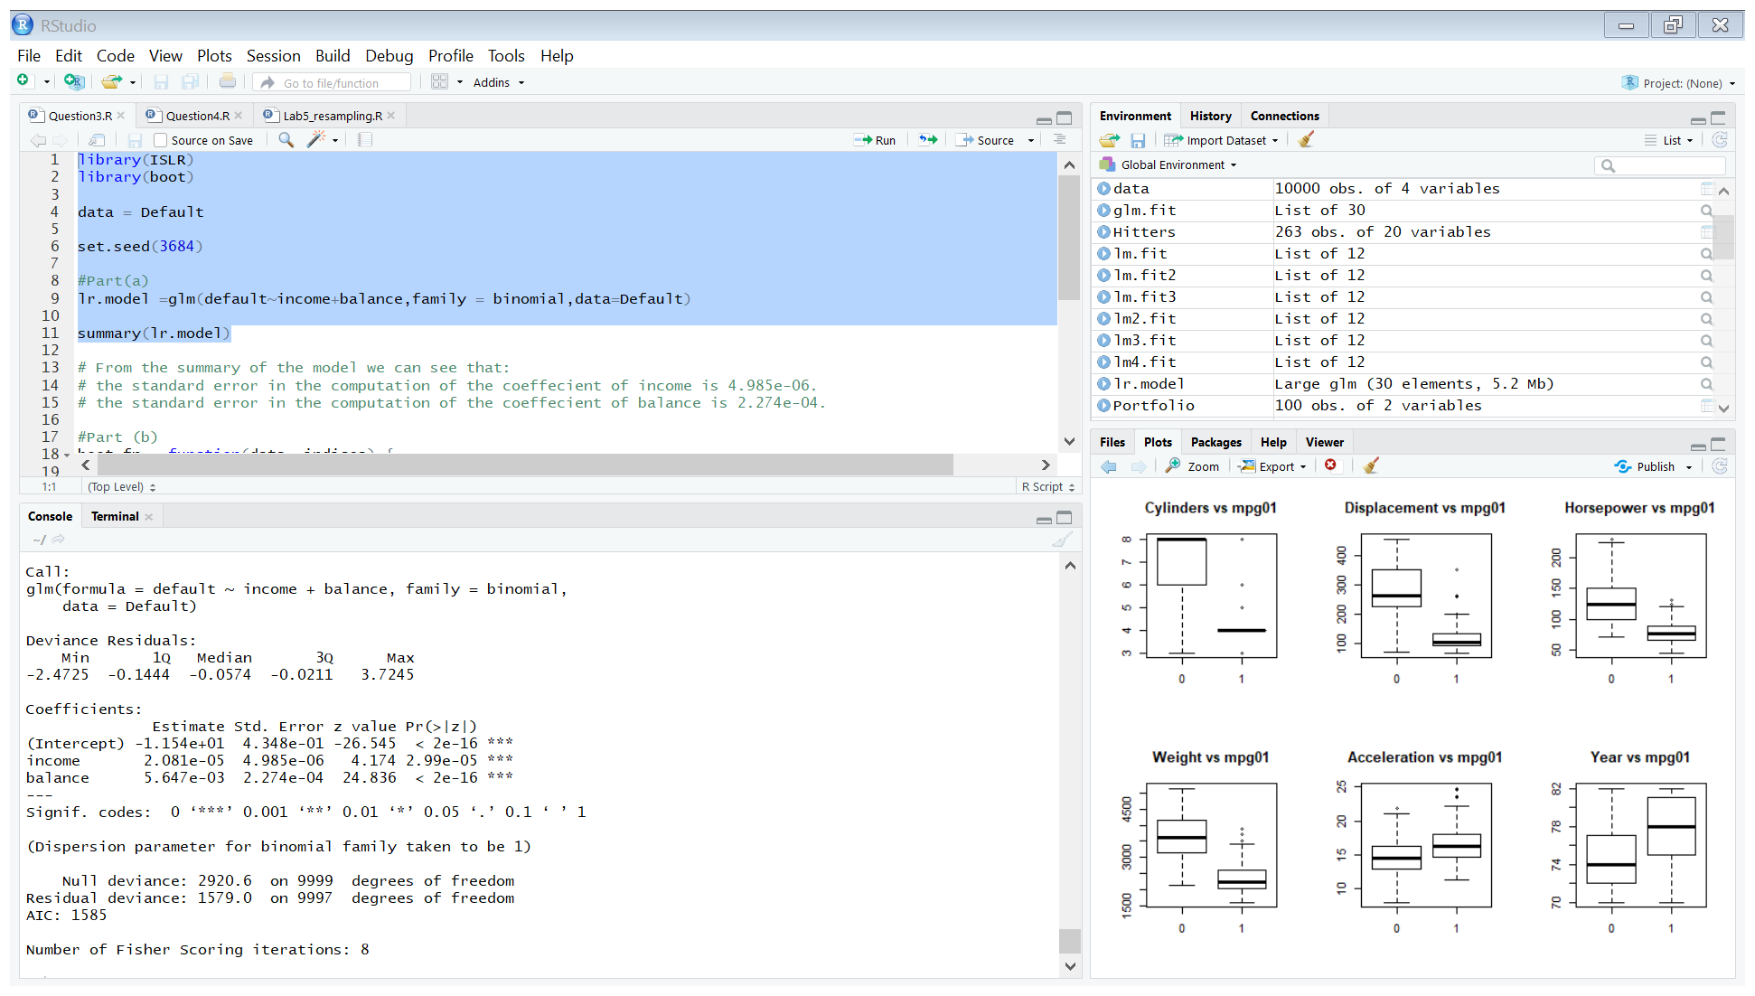

From the summary of the model we can see that:

* The standard error in the computation of the coefficient of income is 4.985e-06.
* The standard error in the computation of the coefficient of balance is 2.274e-04.

**(b)**

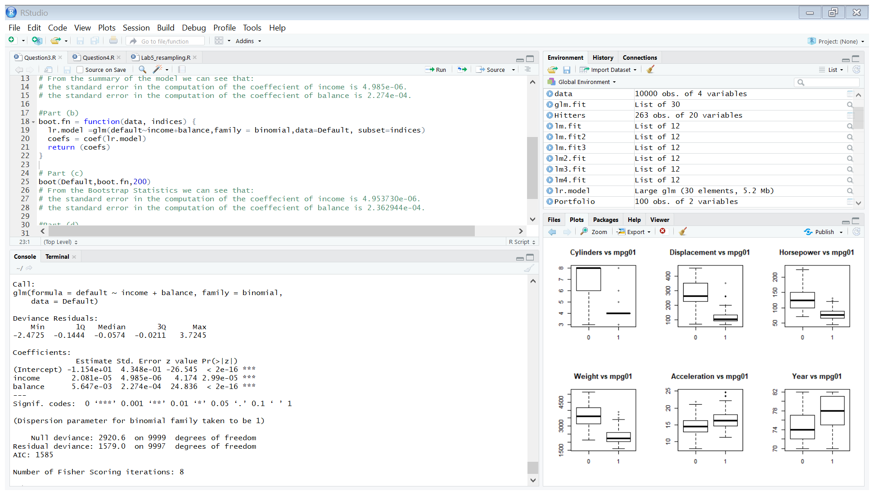

**(c)**

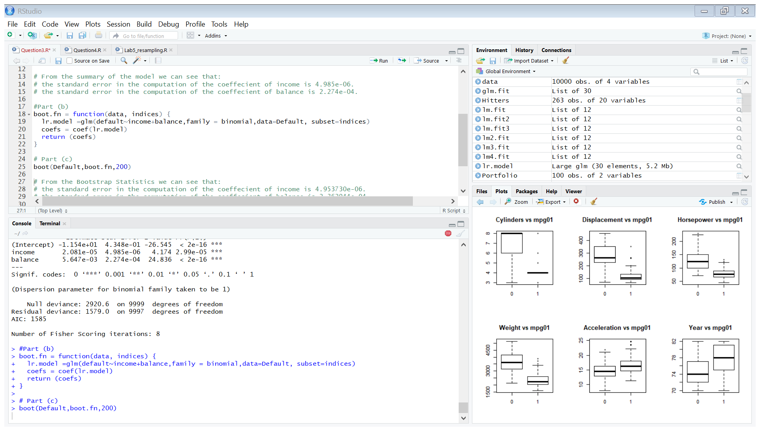

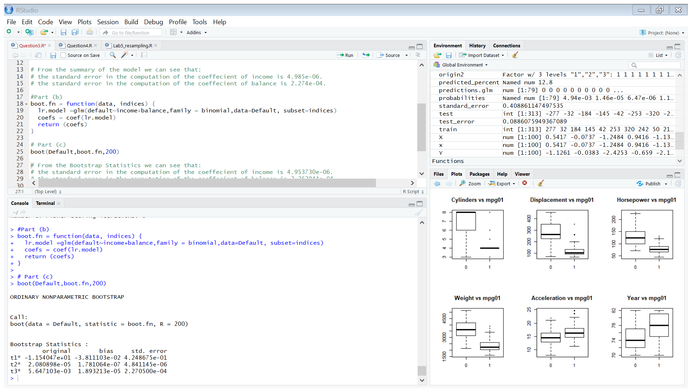

From the Bootstrap Statistics we can see that:

* The standard error in the computation of the coefficient of income is 4.953730e-06.
* The standard error in the computation of the coefficient of balance is 2.362944e-04.

**(d)**

* We can see that the standard errors in the predicted coefficients from the two methods are very close to each other.

**Question 4.**

**(a)**

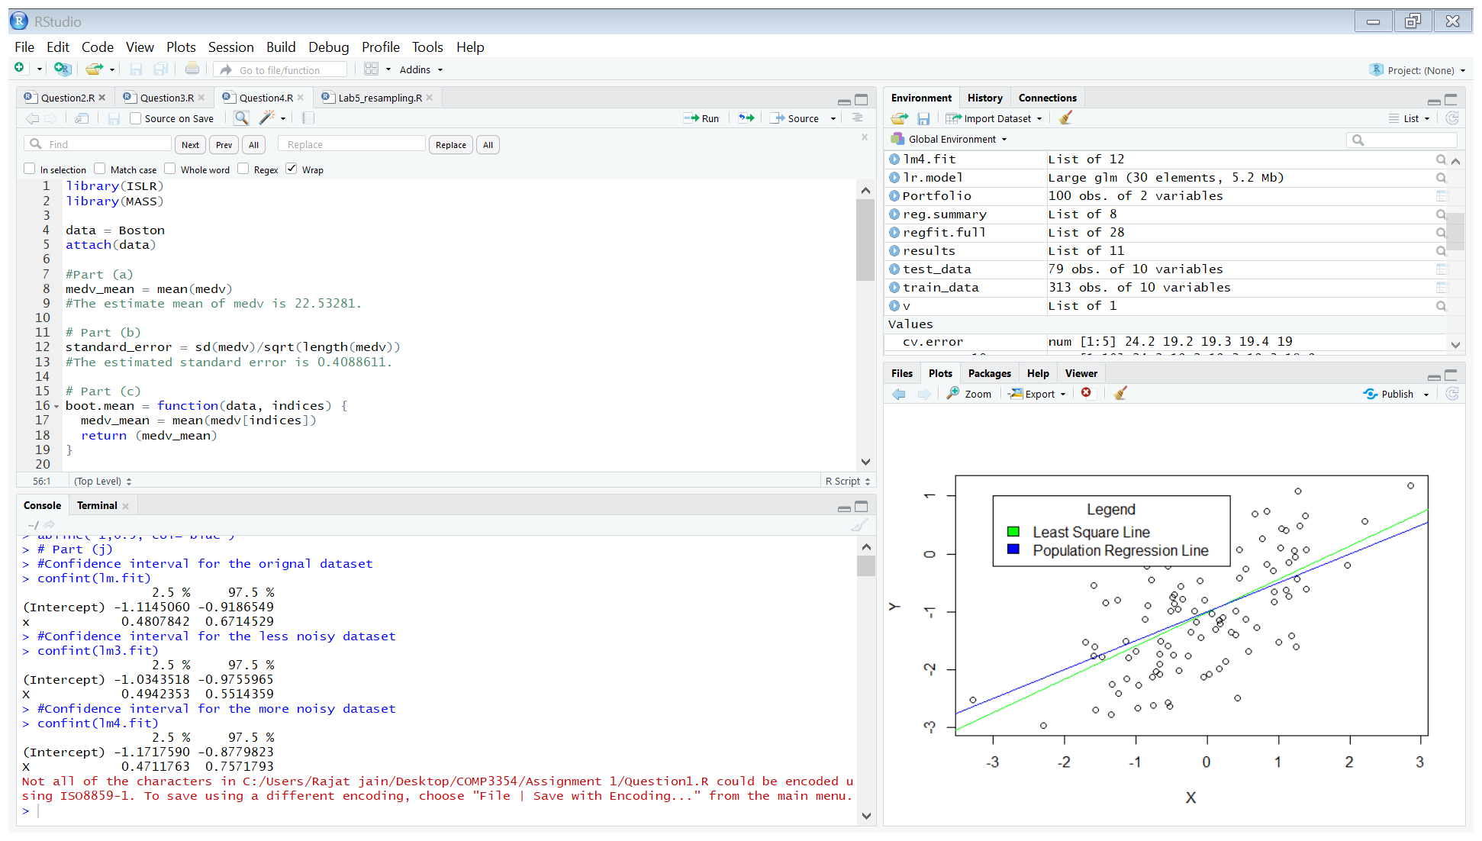

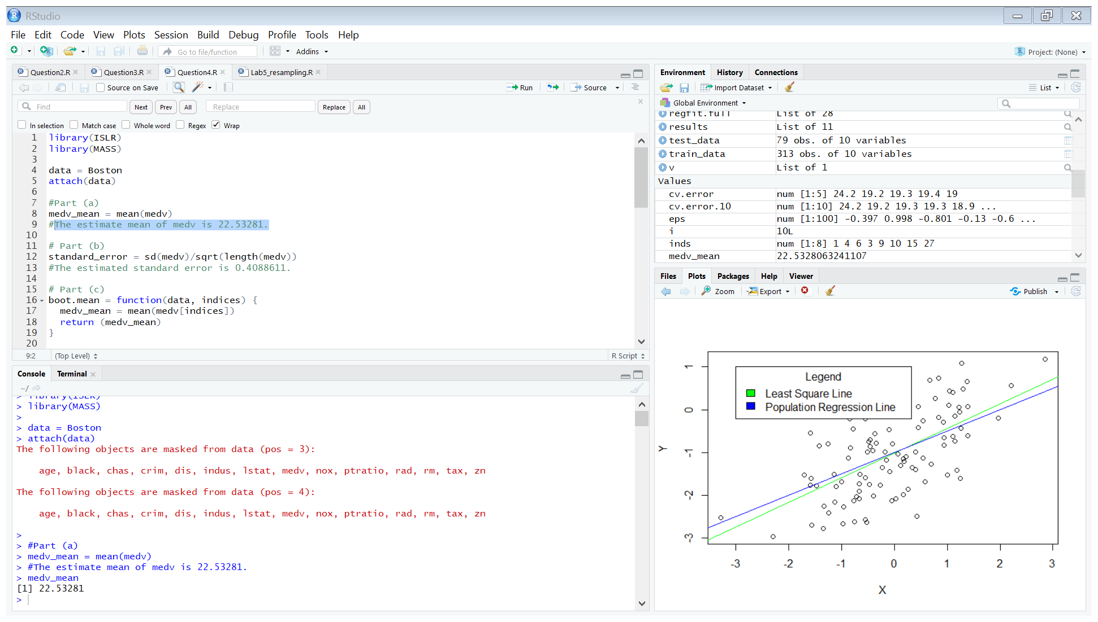

* The estimate mean of medv is 22.53281.

(b)

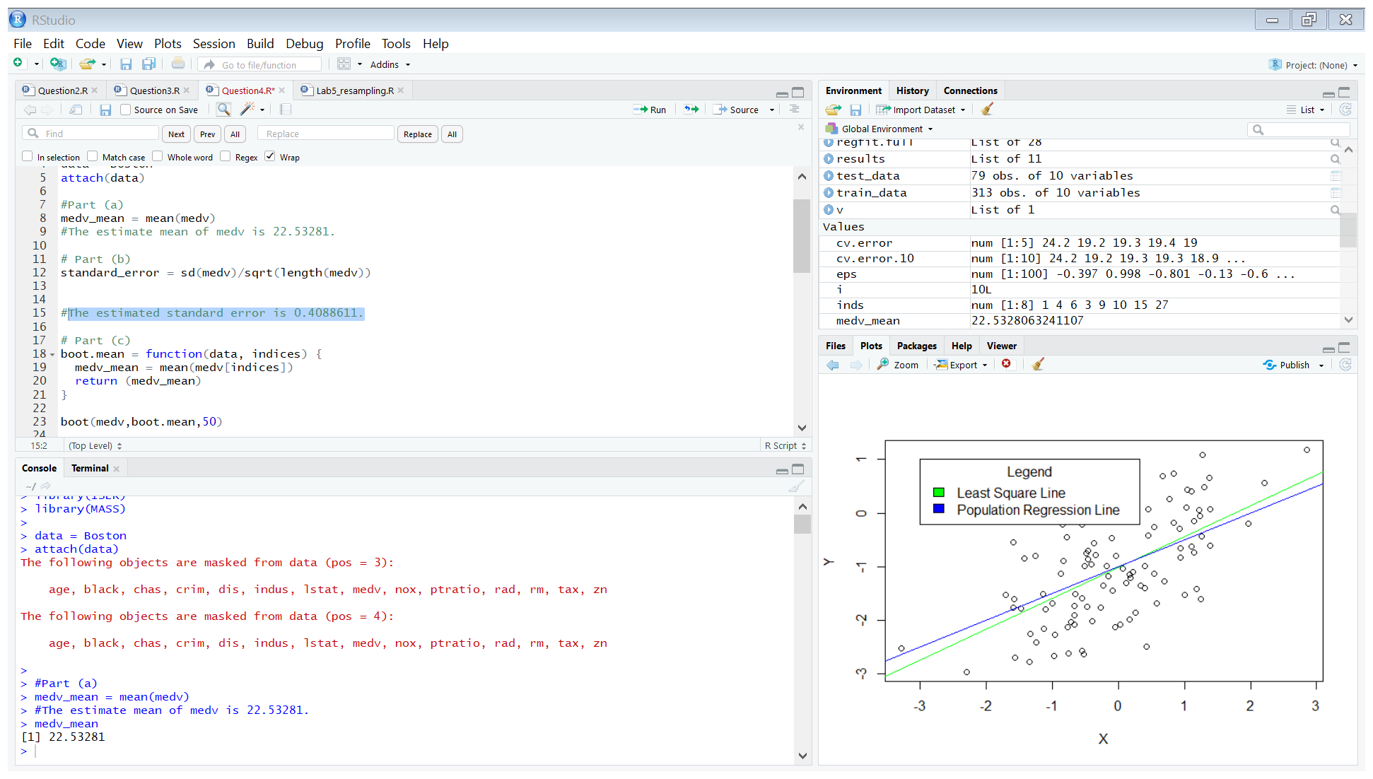

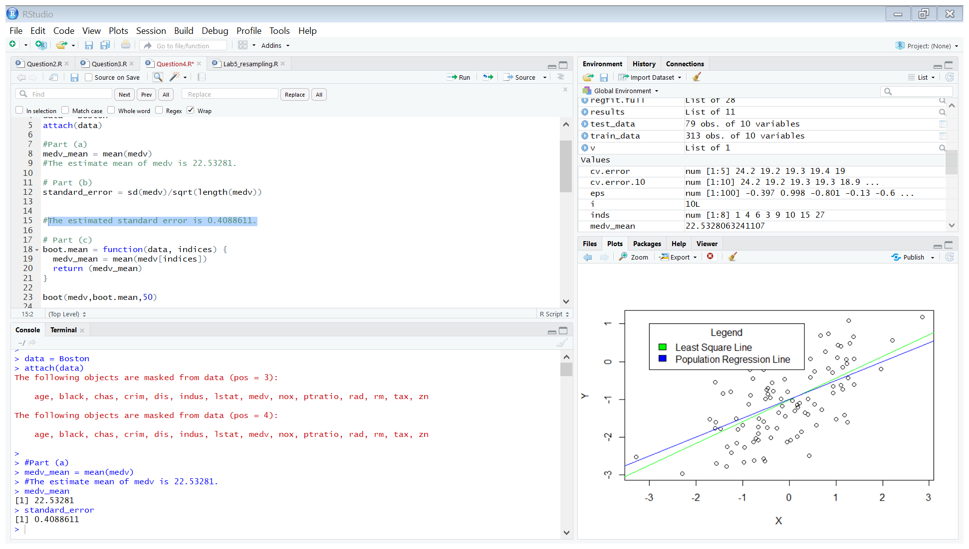

* The standard error in the estimation of the mean is 0.4088611.

(c)

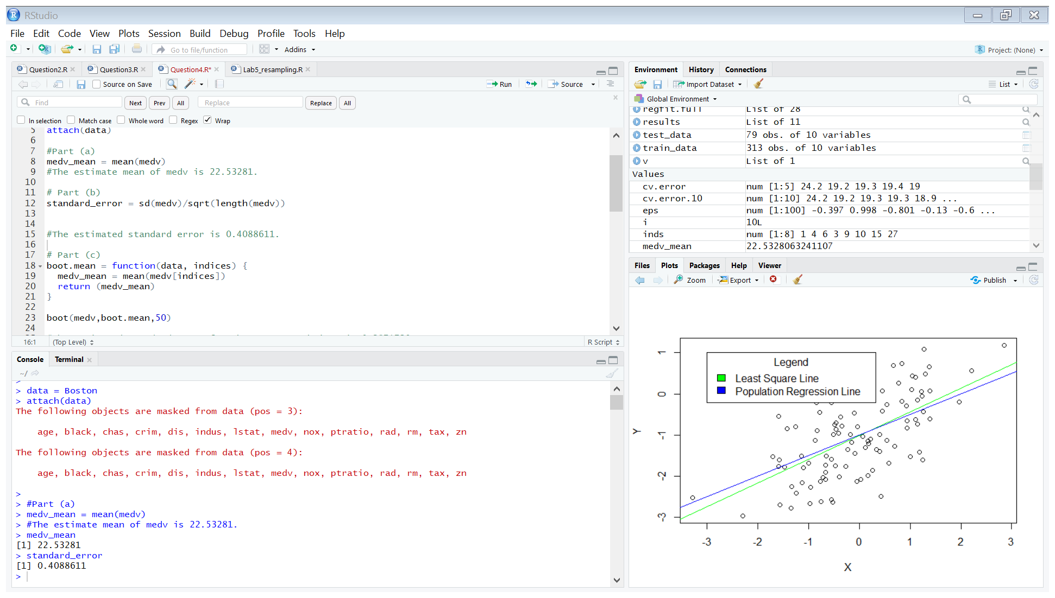

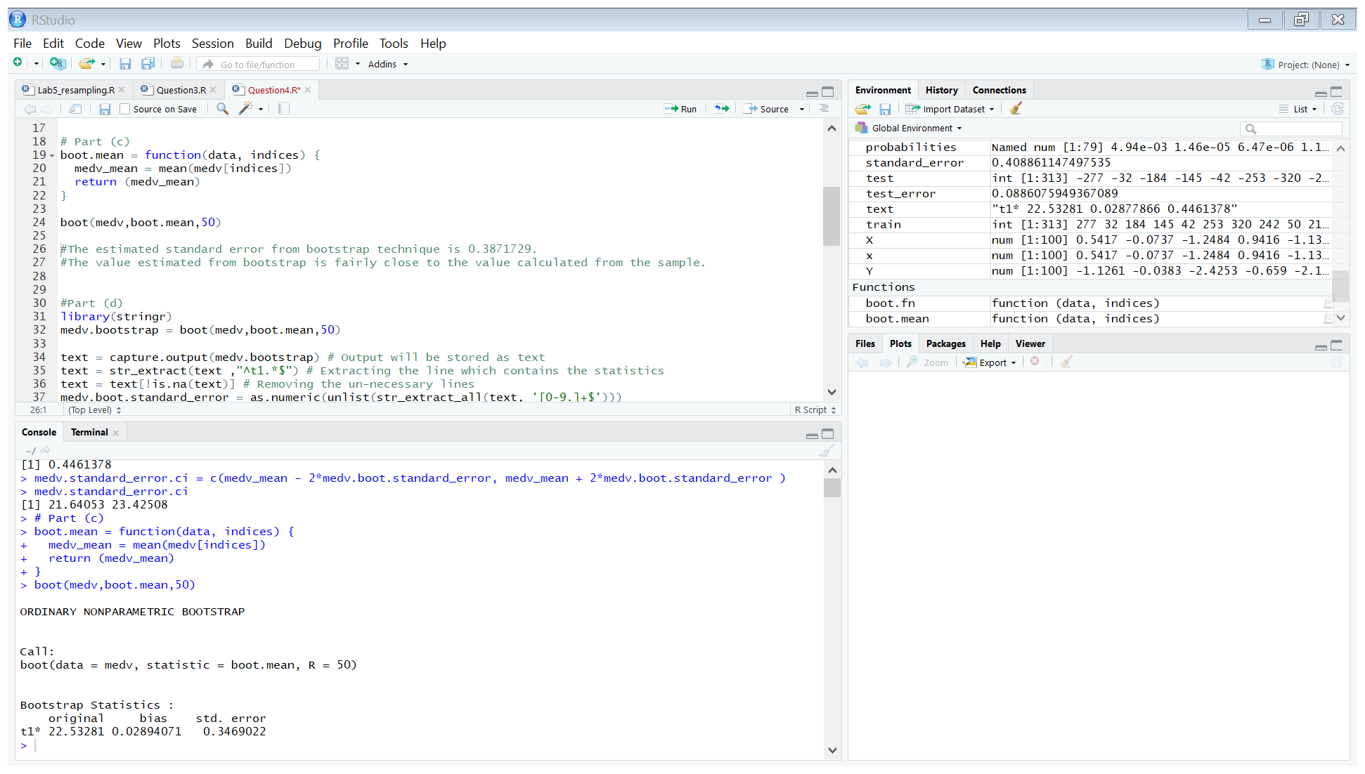

* The estimated standard error from bootstrap technique is 0.3469022.
* The value estimated from bootstrap is close to the value calculated from the sample.

(d)

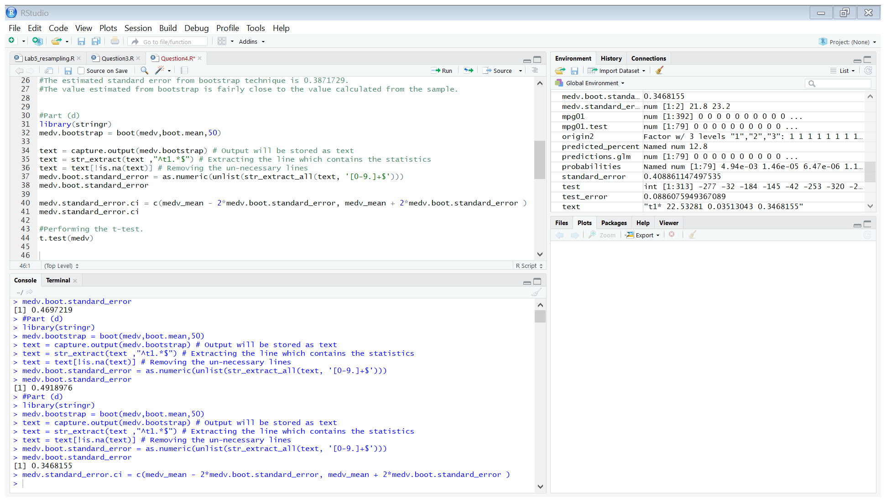

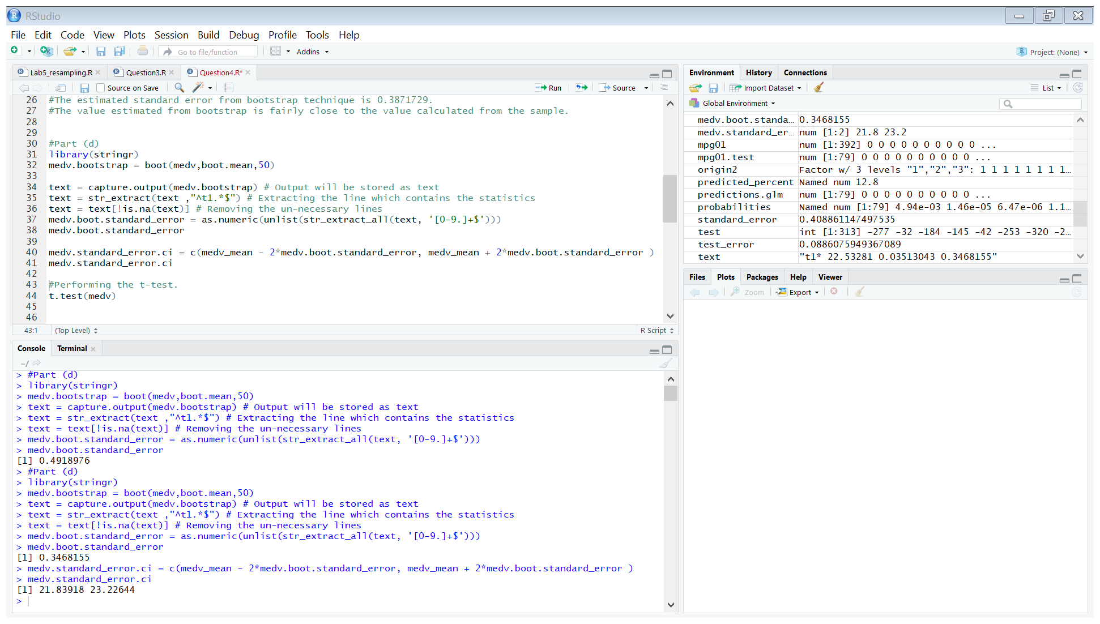

* The 95 % confidence interval for the mean of medv is [21.83918, 23.22644].

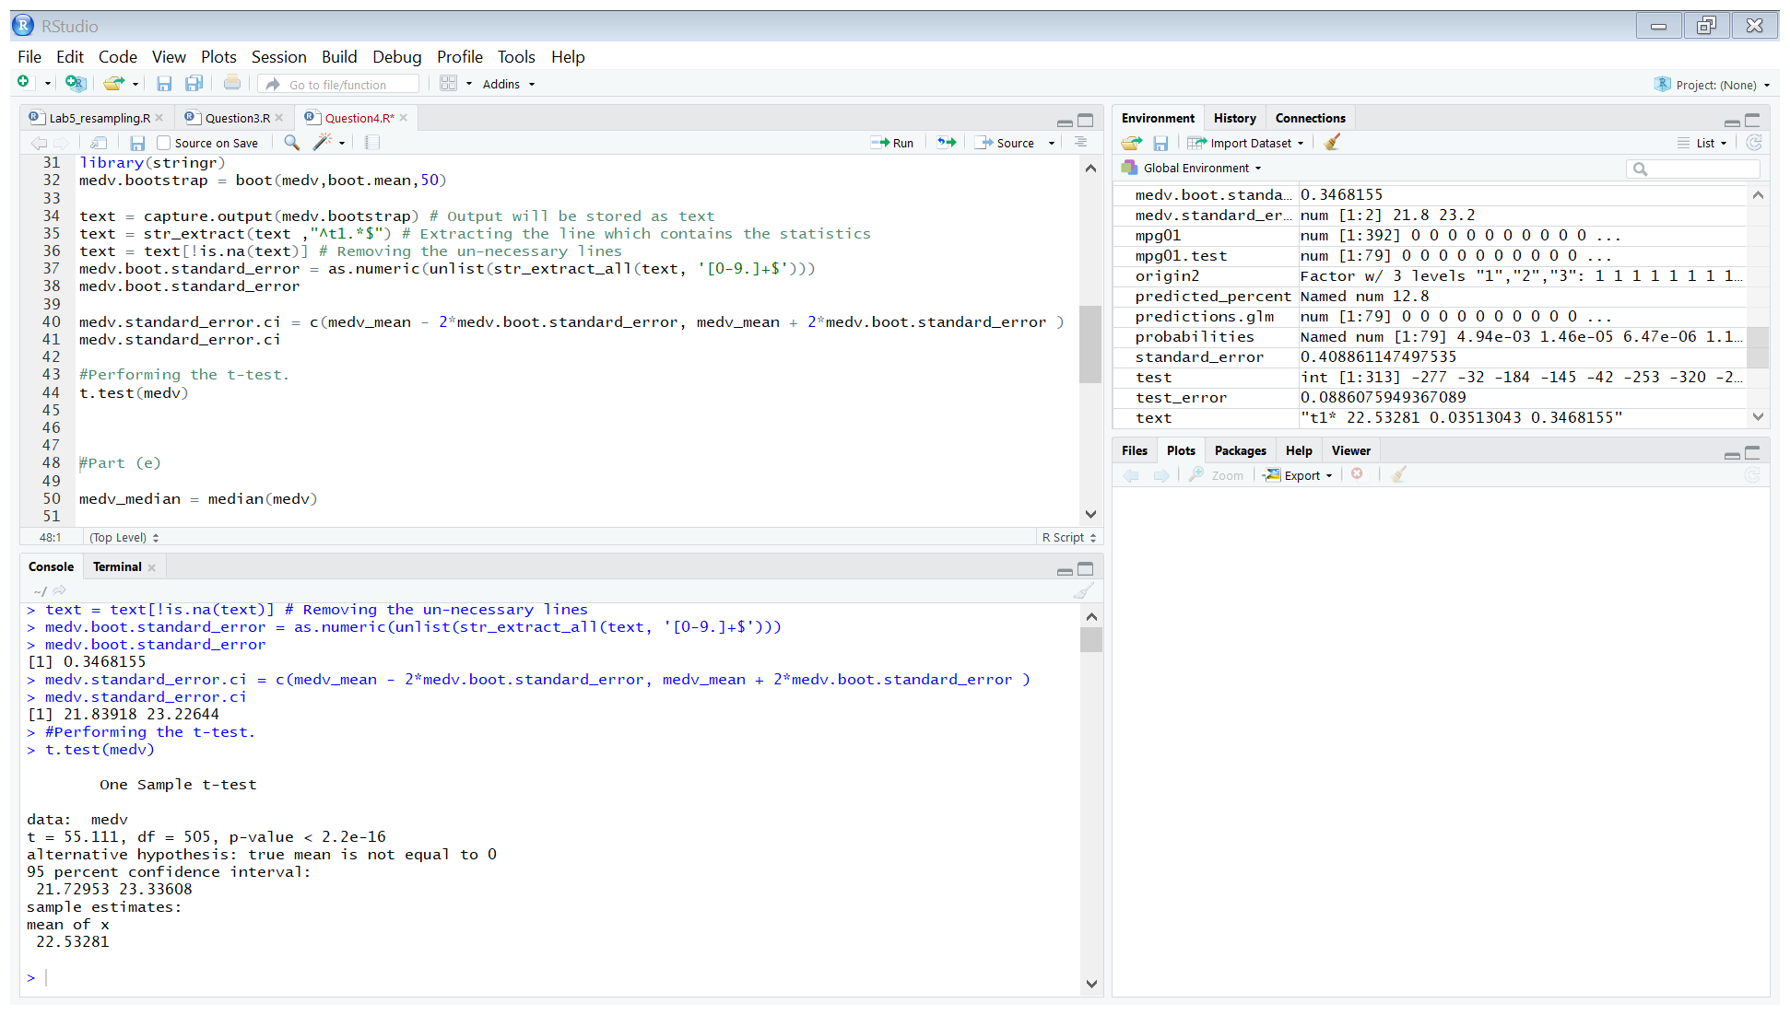

* The confidence interval obtained from t-test is [21.72953, 23.33608].
* The width of the confidence of interval obtained from the two methods are very similar.

(e)

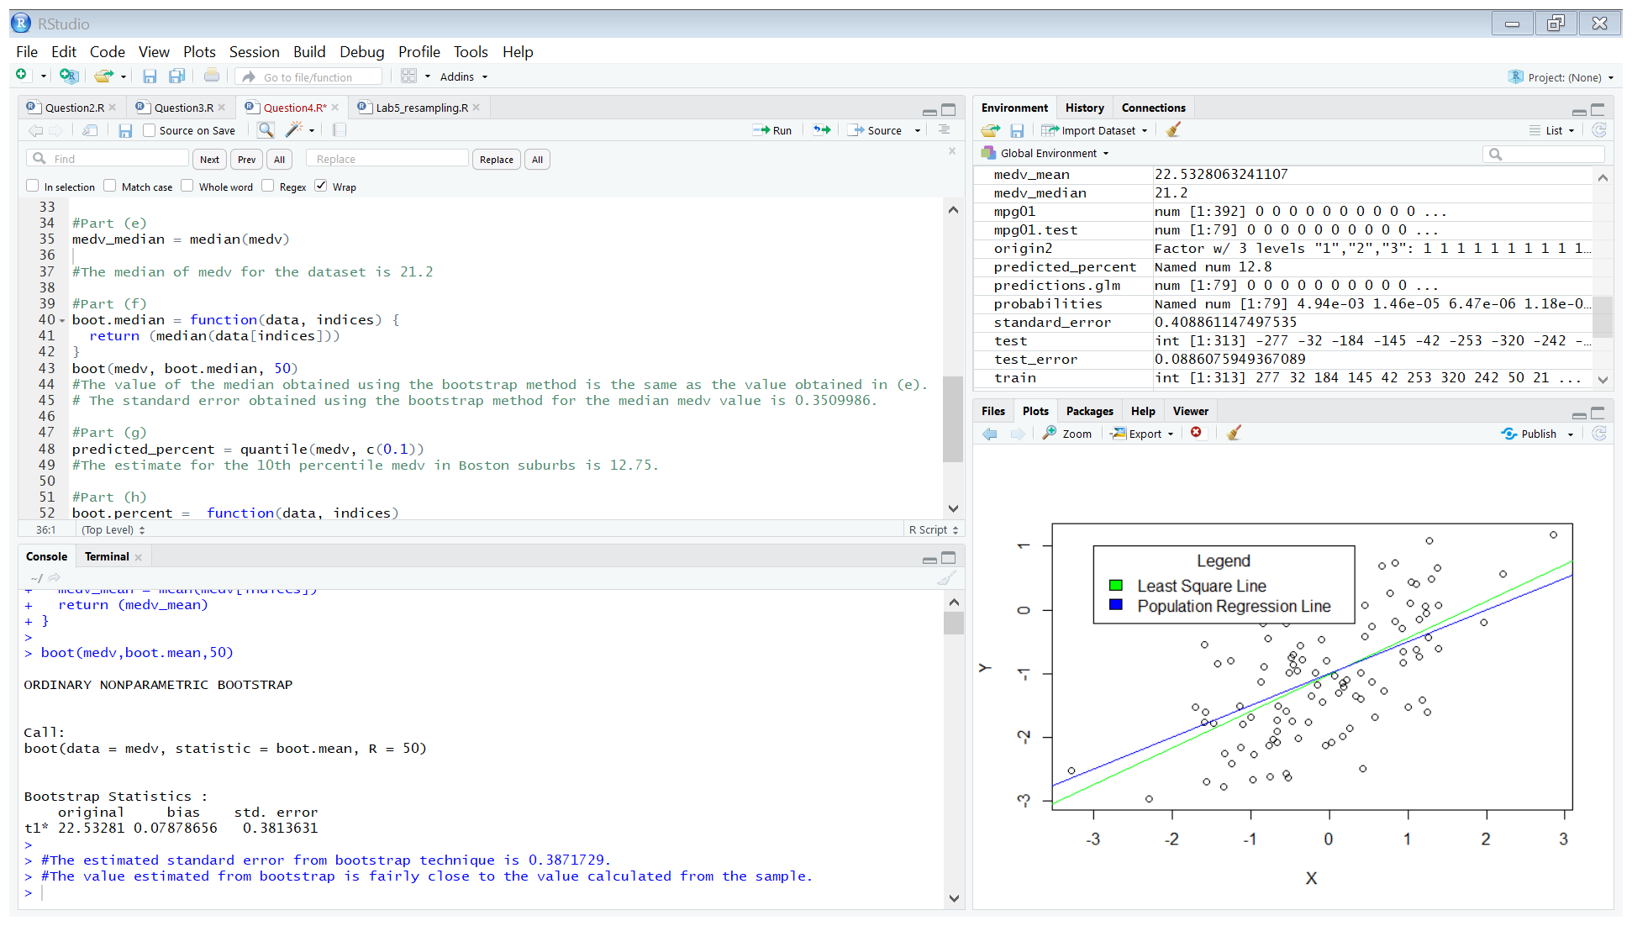

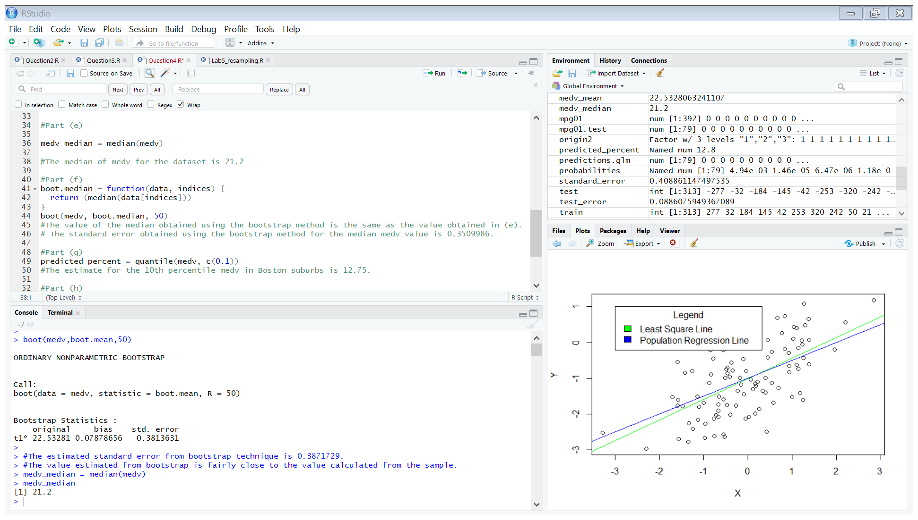

* The median of medv for the dataset is 21.2

(f)

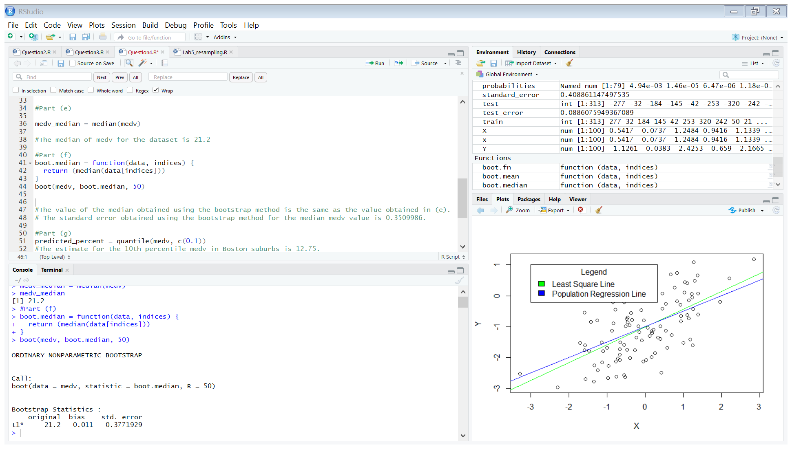

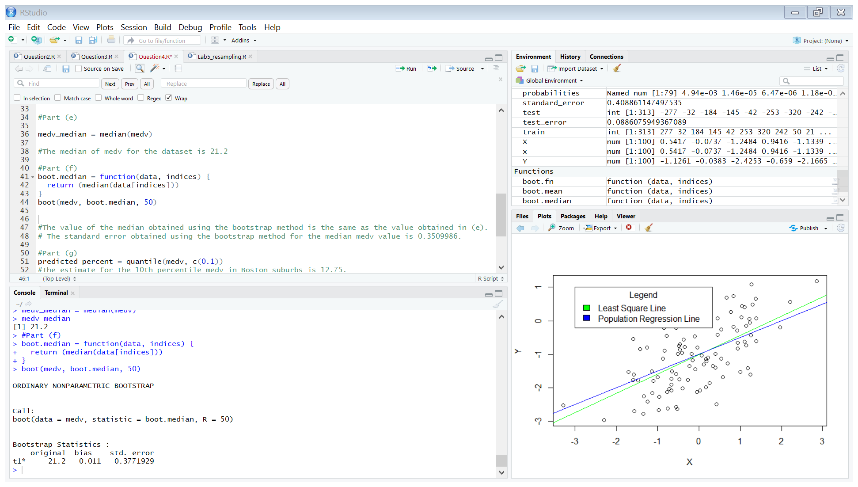

* The value of the median obtained using the bootstrap method is the same as the value obtained in (e).
* The standard error obtained using the bootstrap method for the median medv value is 0.3771929.

(g)

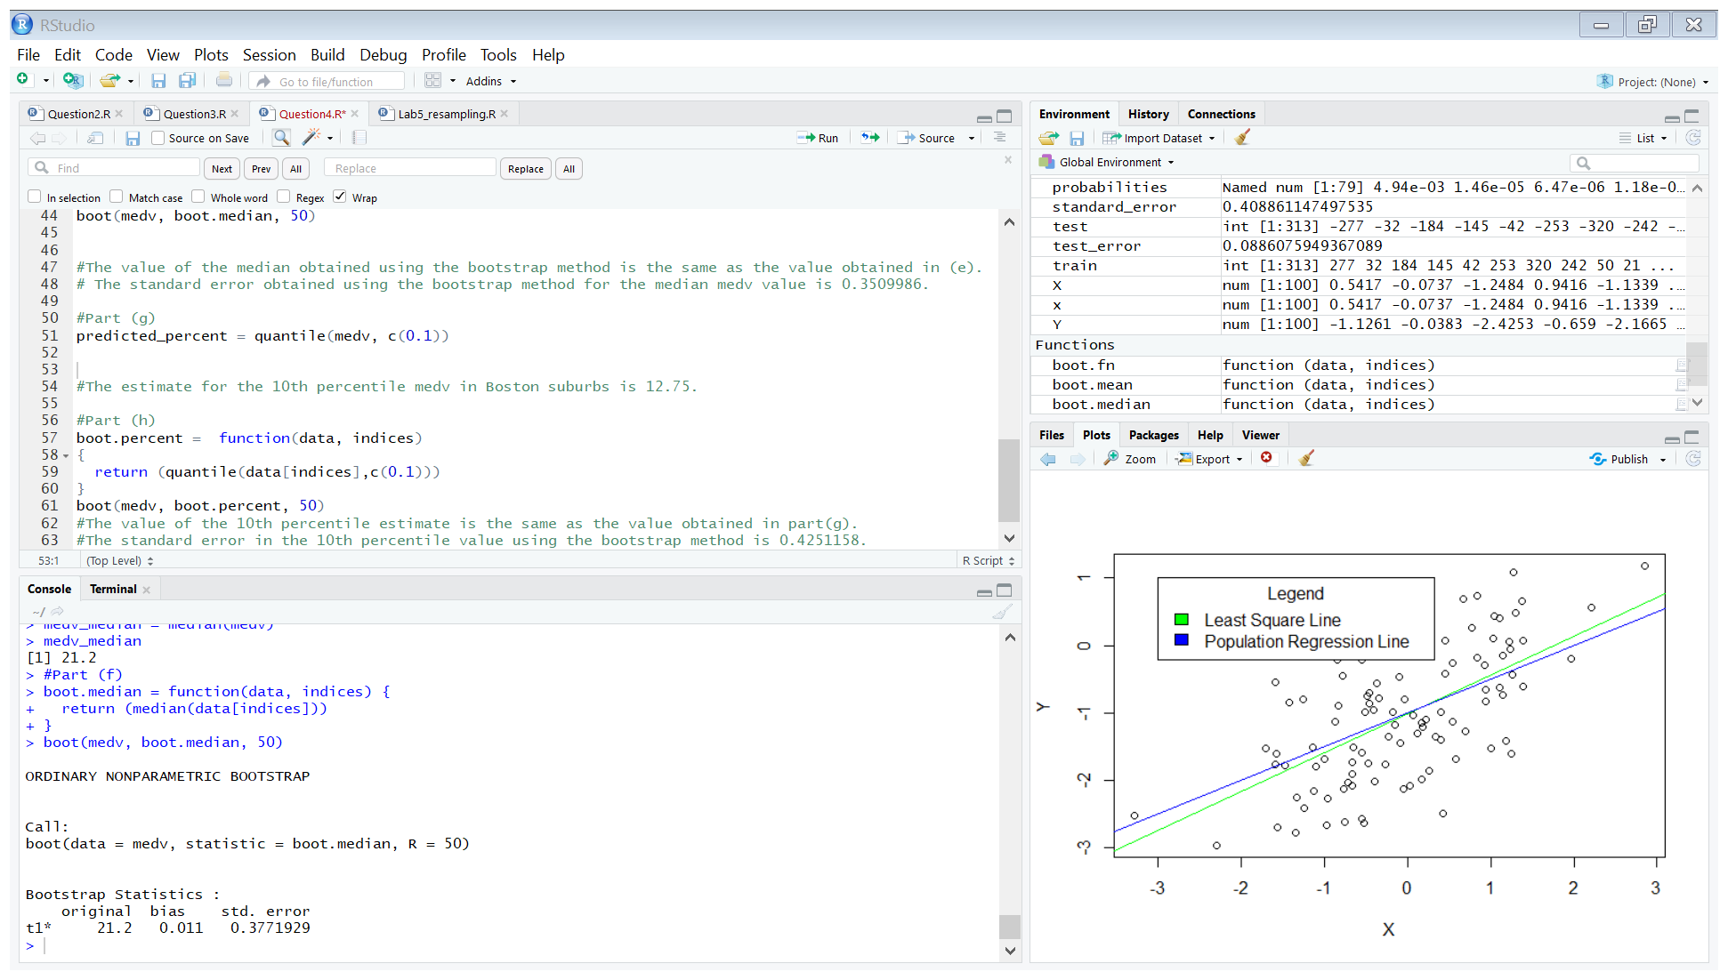

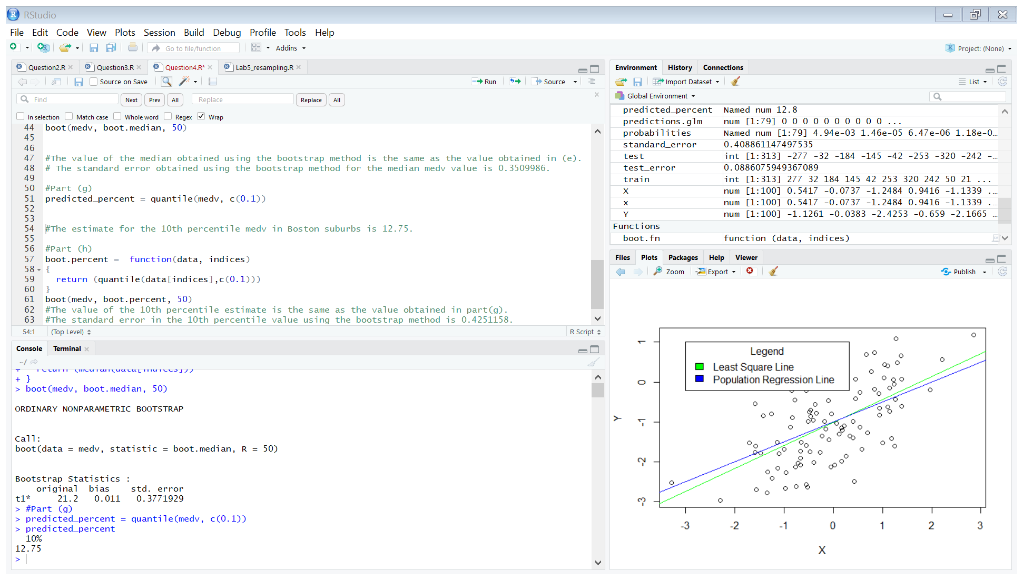

* The estimate for the 10th percentile medv in Boston suburbs is 12.75.

(h)

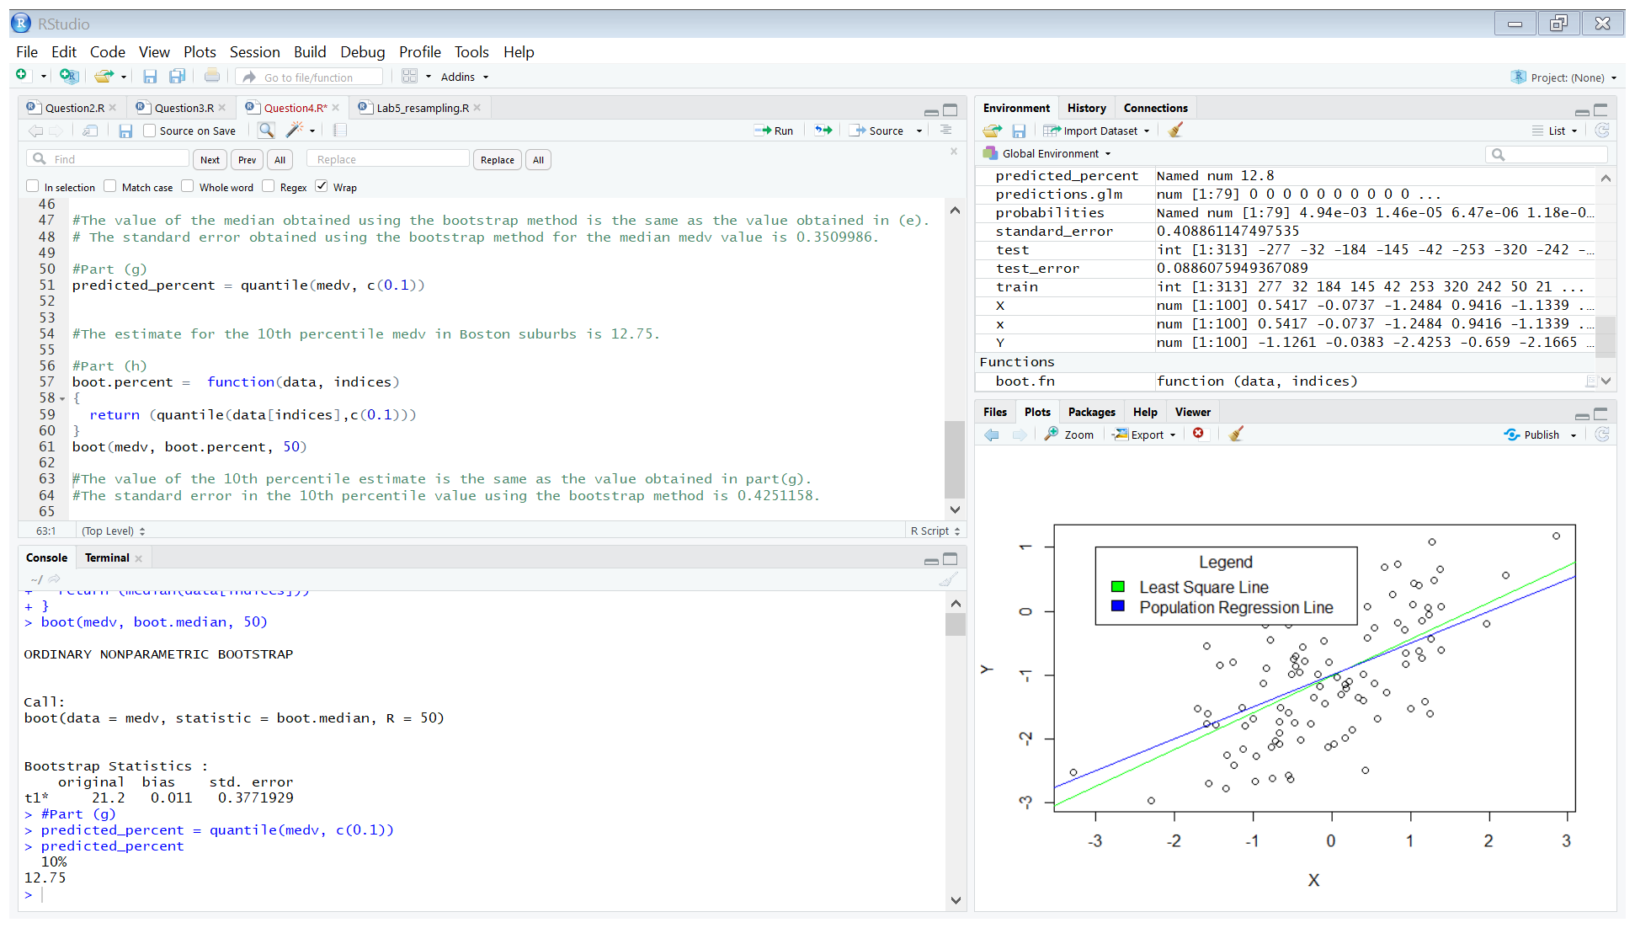

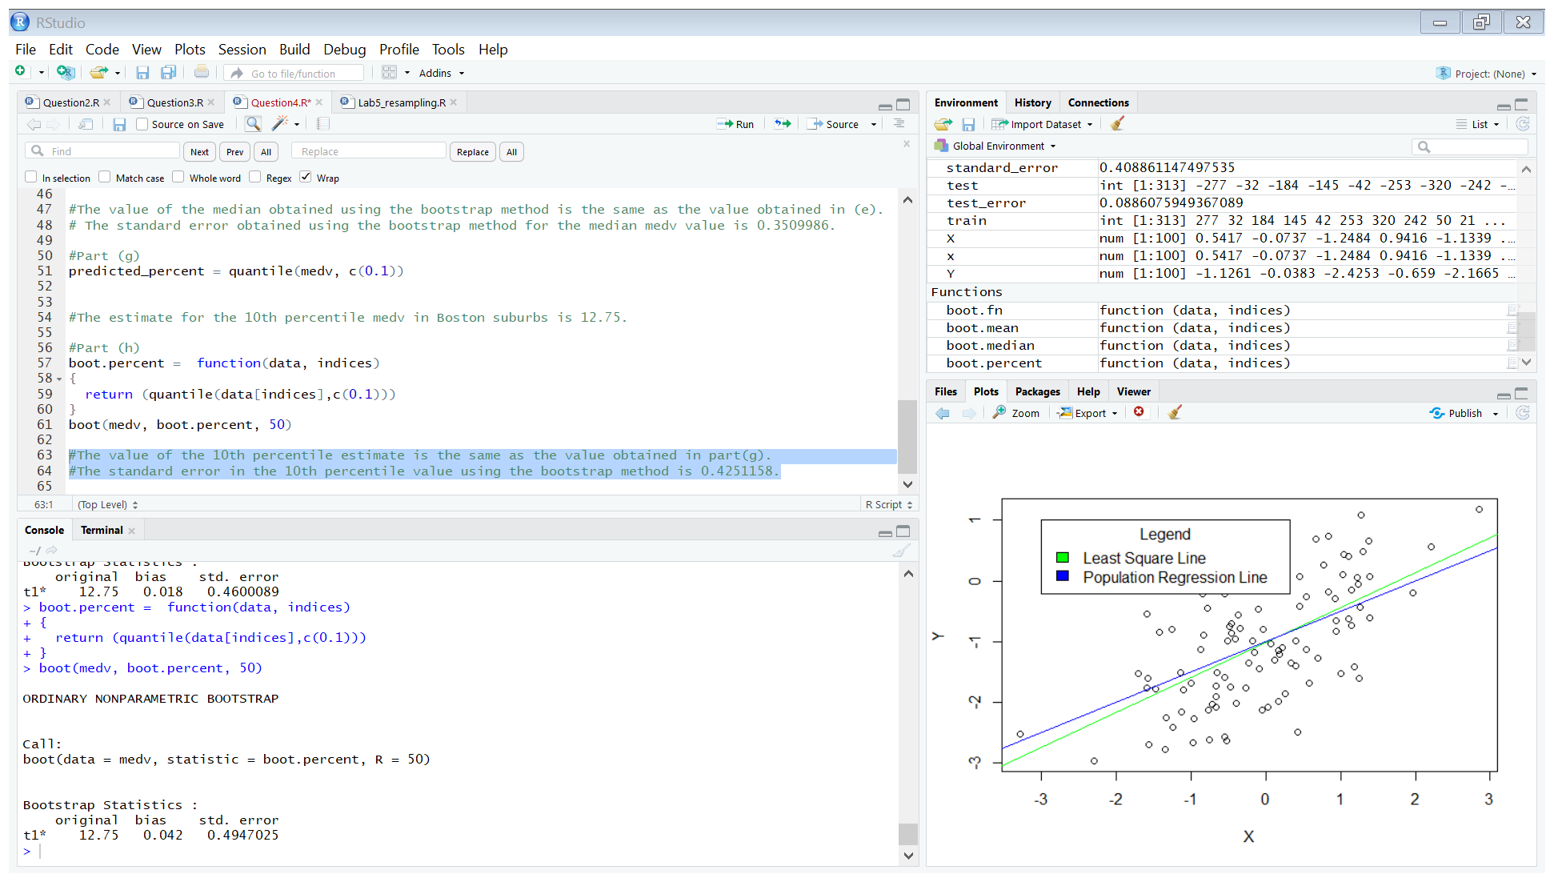

* The value of the 10th percentile estimate is the same as the value obtained in part(g).
* The standard error in the 10th percentile value using the bootstrap method is 0.4947025.